**EXPERIMENT NO. 1**

**ASSIGNMENTS ON JAVA GENERICS**

**EXPERIMENT NO. 1**

**ASSIGNMENTS ON JAVA GENERICS**

**Q.1 Write a Java Program to demonstrate a Generic Class**

**Program:**

package advancejava_fymca;

import java.io.*;

class Test<T>

{

T obj;

Test(T obj)

{

this.obj = obj;

}

public T getObject()

{

System.out.println("Type of T is: "+obj.getClass().getName());

return this.obj;

}

}

public class Gensinglepara

{

public static void main(String[] args)

{

Test<Integer> ob=new Test<Integer>(6);

System.out.println(ob.getObject());

Test<String> ob1=new Test<String>("kartik chopade");

System.out.println(ob1.getObject());

}

}

**Output :**

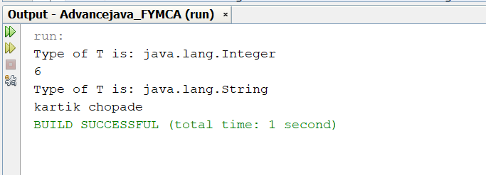

**Q.2 Write a Java Program to demonstrate Generic Methods.**

**Program:**

package advancejava_fymca;

public class Genericclass_twoparameter<T, V>

{

T ob1;

V ob2;

// Pass the constructor a reference to

// an object of type T and an object of type V.

Genericclass_twoparameter(T o1, V o2)

{

ob1 = o1;

ob2 = o2;

}

// Show types of T and V.

void showTypes()

{

System.out.println("Type of T is "+ob1.getClass().getName());

System.out.println("Type of V is "+ob2.getClass().getName());

}

T getob1()

{

return ob1;

}

V getob2()

{

return ob2;

}

}

// Demonstrate TwoGen.

class SimpGen

{

public static void main(String args[])

{

Genericclass_twoparameter<Integer, String> tgObj= new Genericclass_twoparameter<Integer, String>(88, "Generics");

// Show the types.

tgObj.showTypes();

// Obtain and show values.

int v = tgObj.getob1();

System.out.println("value: " + v);

String str = tgObj.getob2();

System.out.println("value: " + str);

}

}

**Output :**

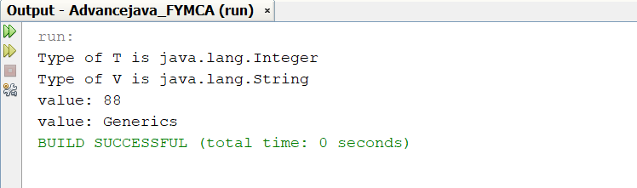

**Generic Method:**

**Program :**

package advancejava_fymca;

public class Genmethod

{

public static<T> void genericDisplay(T element)

{

System.out.println(element.getClass().getName()+"="+element);

}

public static void main(String[] args)

{

genericDisplay(6);

genericDisplay("kartik chopade");

}

}

**Output :**

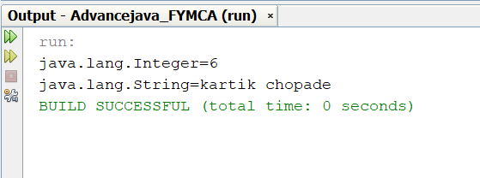

**Q.3 Write a Java Program to demonstrate Wildcards in Java Generics.**

**Program :**

package advancejava_fymca;

import java.io.*;

import java.util.*;

public class wildcardGen

{

private static double sum(List<? extends Number> list)

{

double sum=0.0;

for (Number i: list)

{

sum+=i.doubleValue();

}

return sum;

}

public static void main(String[] args)

{

List<Integer> list1= Arrays.asList(4,5,6,7);

System.out.println("Total sum is:"+sum(list1));

List<Double> list2=Arrays.asList(4.1,5.1,6.1);

System.out.print("Total sum is:"+sum(list2));

}

}

**Output:**

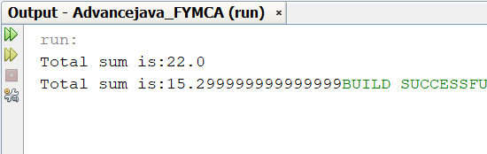

**EXPERIMENT NO. 2**

**ASSIGNMENTS ON LIST INTERFACE**

**EXPERIMENT NO. 2**

**ASSIGNMENTS ON LIST INTERFACE**

**Q.1 Write a Java program to create List containing list of items of type String and use for- --each loop to print the items of the list.**

**Program :**

package advancejava_fymca;

import java.util.*;

public class List_practical2

{

public static void main(String[] args)

{

List<String> list=new ArrayList<String>();

list.add("Mango");

list.add("Apple");

list.add("Banana");

list.add("Grapes");

for(String fruit:list)

System.out.println(fruit);

}

}

**Output :**

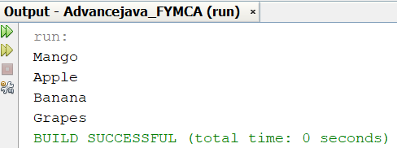

**Q.2 Write a Java program to create List containing list of items and use ListIterator interface to print items present in the list. Also print the list in reverse/ backword direction.**

**Program :**

package advancejava_fymca;

import java.util.*;

public class ListIterator_practical2

{

public static void main(String[] args)

{

List<String> al=new ArrayList<String>();

al.add("Amit");

al.add("Vijay");

al.add("Kumar");

al.add(1,"Sachin");

ListIterator<String> itr=al.listIterator();

System.out.println("Traversing element in forward direction");

while(itr.hasNext())

{

System.out.println("index:"+itr.nextIndex()+"value:"+itr.next());

}

System.out.println("Traversing elements in backward");

while(itr.hasPrevious())

{

System.out.println("index:"+itr.previousIndex()+"value:"+itr.previous());

}

}

}

**Output :**

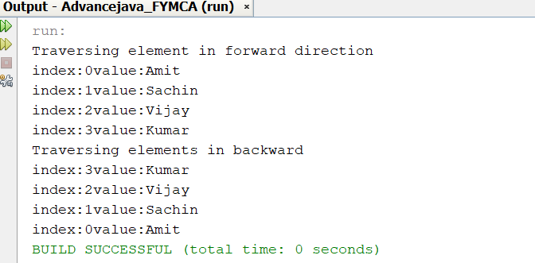

**EXPERIMENT NO. 3**

**ASSIGNMENTS ON LIST INTERFACE**

**EXPERIMENT NO. 3**

**ASSIGNMENTS ON LIST INTERFACE**

**Q.1 Write a Java program to create a Set containing list of items of type String and print the items in the list using Iterator interface. Also print the list in reverse/backword direction.**

**Program:**

package advancejava_fymca;

import java.io.*;

import java.util.*;

public class Setinterface_practical3

{

public static void main(String[] args)

{

Set data=new HashSet();

data.add("kartik");

data.add("Kiran");

data.add("Anuja");

data.add("shubham");

//System.out.println("Data:"+data);

List al = new ArrayList(data);

ListIterator alt=al.listIterator();

System.out.println("......Forward Direction:");

while(alt.hasNext())

{

System.out.println("index:"+alt.previousIndex()+" value:"+alt.next());

}

System.out.println("......Backward Direction:");

while(alt.hasPrevious())

{

System.out.println("index:"+alt.previousIndex()+" value:"+alt.previous());

}

}

}

**Output :**

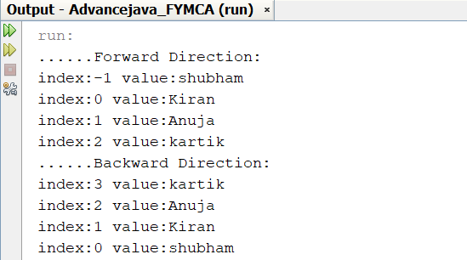

**Q.2 Write a Java program using Set interface containing list of items and perform the following operations:**

**a. Add items in the set.**

**b. Insert items of one set in to other set.**

**c. Remove items from the set**

**d. Search the specified item in the set**

**Program:**

package advancejava_fymca;

import java.io.*;

import java.util.*;

public class SetInterface2_practical_3

{

public static void main(String[] args)

{

Set<Integer> data=new LinkedHashSet<Integer>();

data.add(31);

data.add(21);

data.add(41);

System.out.println("Set: "+data);

ArrayList<Integer> newData=new ArrayList<Integer>();

newData.add(91);

newData.add(71);

newData.add(81);

data.addAll(newData);

System.out.println("Set: "+data);

data.remove(81);

data.remove(21);

data.remove(11);

System.out.println("data after removing elements: "+data);

data.removeAll(newData);

System.out.println("data after removing Newdata elements: "+data);

System.out.println("Set: "+data);

System.out.println("Does the set contain 91 "+data.contains(91));

System.out.println("Does the set contain javaTpoint "+data.contains("4"));

System.out.println("Does the set contain 51 "+data.contains(51));

System.out.println("\nDoes data contains newData: "+data.containsAll(newData));

}

}

**Output :**

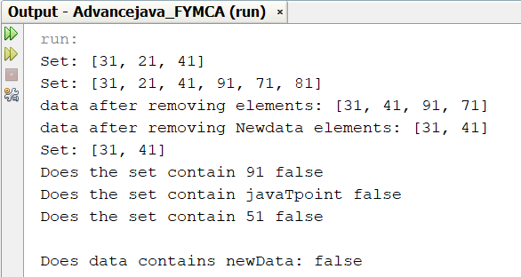

**EXPERIMENT NO. 4**

**ASSIGNMENTS ON MAP INTERFACE**

**EXPERIMENT NO. 4**

**ASSIGNMENTS ON MAP INTERFACE**

**Q.1** **Write a Java program using Map interface containing list of items having keys and associated values and perform the following operations:**

**a. Add items in the map.**

**b. Remove items from the map**

**c. Search specific key from the map**

**d. Get value of the specified key**

**e. Insert map elements of one map in to other map.**

**f. Print all keys and values of the map.**

**Program :**

package advancejava_fymca;

import java.io.*;

import java.util.*;

public class MapInterface

{

public static void main(String[] args)

{

HashMap<Integer,String> map=new HashMap<Integer,String>();

map.put(1,"ABC");

map.put(2,"PQR");

map.put(3,"XYZ");

map.put(4,"MNO");

map.put(5,"LMN");

System.out.println("Map List 1: ");

System.out.println(map);

System.out.println("-----------------------------------------------------");

HashMap<String,Integer> map1=new HashMap<String,Integer>();

map1.put("Apple",10);

map1.put("Banana",20);

map1.put("Orange",30);

System.out.println("Map List2: ");

System.out.println(map1);

System.out.println("-----------------------------------------------------");

System.out.println("1 is remove from the list");

map.remove(1);

System.out.println("Update list of element: "+map);

System.out.println("-----------------------------------------------------");

System.out.println("Search Apple the key is");

System.out.println("The value is: "+map1.get("Apple"));

System.out.println("-----------------------------------------------------");

System.out.println("Get value of key 5");

System.out.println("The value is: "+map.get(5));

System.out.println("-----------------------------------------------------");

System.out.println("Insert map elements of one map in to other map");

HashMap<Integer, String> new_map = new HashMap<Integer, String>();

new_map.putAll(map);

System.out.println("The new map looks like this: " + new_map);

System.out.println("-----------------------------------------------------");

Iterator<Map.Entry<Integer, String>> itr = map.entrySet().iterator();

System.out.println("Print all keys and values of the map");

while(itr.hasNext())

{

Map.Entry<Integer, String> entry = itr.next();

System.out.println("Key = " + entry.getKey() +

", Value = " + entry.getValue());

}

System.out.println("-----------------------------------------------------");

Iterator<Map.Entry<String,Integer>> itr1 = map1.entrySet().iterator();

System.out.println("Print all keys and values of the map1");

while(itr1.hasNext())

{

Map.Entry<String,Integer> entry = itr1.next();

System.out.println("Key = " + entry.getKey() +

", Value = " + entry.getValue());

}

System.out.println("-----------------------------------------------------");

}

}

**Output :**

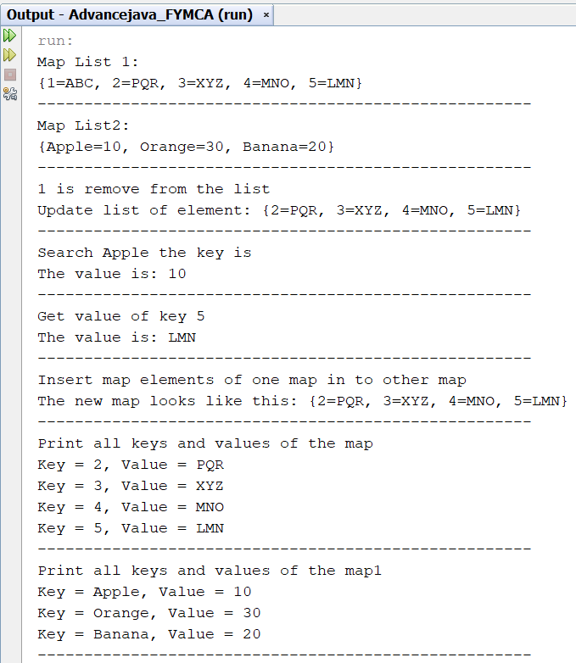

**EXPERIMENT NO. 5**

**ASSIGNMENTS ON LAMBDA EXPRESSION**

**EXPERIMENT NO. 5**

**ASSIGNMENTS ON LAMBDA EXPRESSION**

**Q1. Write a Java program using Lambda Expression to print “Hello World”.**

**Program :**

package advancejava_fymca;

import java.io.*;

interface helloworld

{

String sayhello();

}

public class Lamdahello

{

public static void main(String[] args)

{

helloworld h1= ()->

{

return "Hello World ";

};

System.out.println(h1.sayhello());

}

}

**Output :**

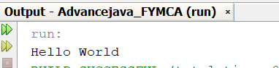

**Q.2 Write a Java program using Lambda Expression with single parameters.**

**Program :**

package advancejava_fymca;

import java.io.*;

interface sayhello

{

String say(String name);

}

public class Lamdasinglepara

{

public static void main(String[] args)

{

sayhello h1=(name)->

{

return "Hello, "+name;

};

System.out.println(h1.say("Kartik chopade"));

}

}

**Output :**

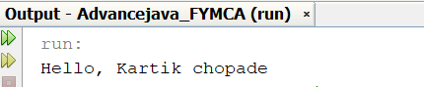

**Q.3 Write a Java program using Lambda Expression with multiple parameters to add two numbers.**

**Program :**

package advancejava_fymca;

import java.io.*;

interface Addition

{

int add(int num1,int num2);

}

public class Lamdatwopara

{

public static void main(String[] args)throws Exception

{

Addition h1=(num1,num2)->(num1+num2);

System.out.println("Addition is: "+h1.add(10,50));

}

}

**Output :**

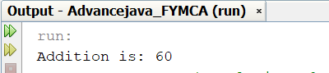

**Q.4 Write a Java program using Lambda Expression to calculate the following:**

**a. Convert Fahrenheit to Celcius**

**b. Convert Kilometers to Miles**

**Program:**

package advancejava_fymca;

import java.io.*;

interface Converter

{

double convert(double x);

}

public class LamdaFtoC

{

public static void main(String[] args)

{

System.out.println("kartikchopade Roll No:6");

// Convert Fahrenheit to Celsius

Converter c=(n)-> {

double c1;

c1=(n-32)*5.0/9.0;

return c1;

};

System.out.println("Converted Fahrenheit to Celsius: "+c.convert(80.8));

// Convert Kilometers to Miles

Converter m=(n)-> {

double m1;

m1=n/1.609344;

return m1;

};

System.out.println("Converted Kilometers to Miles: "+m.convert(6));

}

}

**Output :**

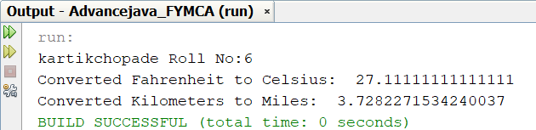

**Q.5 Write a Java program using Lambda Expression with or without return keyword.**

**Program :**

package advancejava_fymca;

import java.io.*;

interface Addition1

{

int add(int a,int b);

}

public class LamdaReturn

{

public static void main(String[] args)

{

System.out.println("Kartik chopade:6");

Addition1 sum1=(a,b)->(a+b);

System.out.println("Addition of Two no: "+sum1.add(2,3));

Addition1 sum2=(a,b)->{

return (a+b);

};

System.out.println("Addition of Two no: "+sum2.add(3,9));

}

}

**Output :**

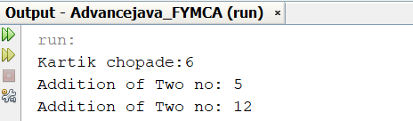

**Q.6 Write a Java program using Lambda Expression to concatenate two strings.**

**Program :**

package advancejava_fymca;

interface StringFunc

{

String func(String n,String m);

}

public class LamdaConcatnet

{

public static void main(String[] args)

{

System.out.println("Kartik Chopade:6");

StringFunc concat1= (str1,str2) -> {return str1.concat(str2);};

System.out.println("Concatenate two strings: " +concat1.func("Lambda","Expression"));

}

}

**Output :**

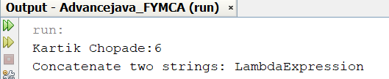

**EXPERIMENT NO. 6**

**ASSIGNMENTS BASED ON WEB APPLICATION DEVELOPMENT USING JSP**

**EXPERIMENT NO. 6**

**ASSIGNMENTS BASED ON WEB APPLICATION DEVELOPMENT USING JSP**

**Q.1 Write a JSP program that demonstrates the use of JSP declaration, scriptlet, directives, expression.**

**A) Declaration**

**Declaration.jsp**

<%@ page language="java" contentType="text/html; charset=ISO-8859-1"

pageEncoding="ISO-8859-1"%>

<!DOCTYPE html>

<html>

<head>

<meta charset="ISO-8859-1">

<title>Insert title here</title>

</head>

<body>

<%! int data=50; %>

<%= "Value of the variable is:"+data %>

</body>

</html>

**Output:**

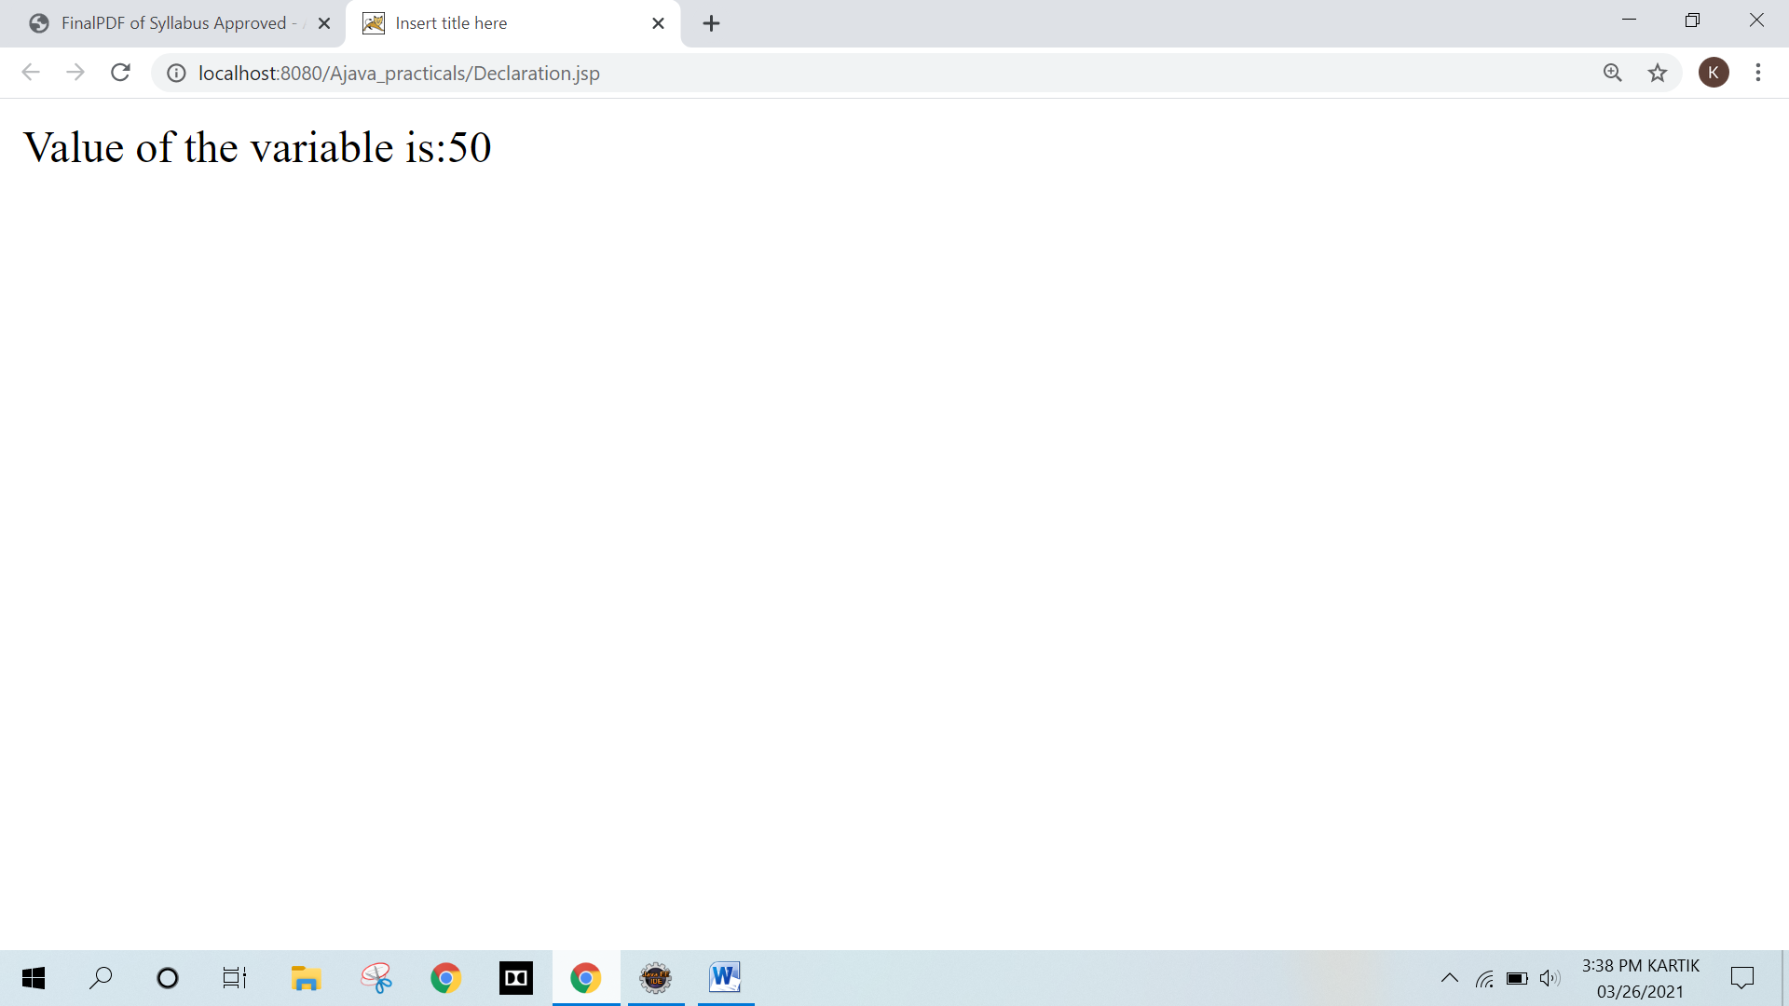

**B) Scriptlet**

**Design.html**

<!DOCTYPE html>

<html>

<head>

<meta charset="ISO-8859-1">

<title>Insert title here</title>

</head>

<body>

<form action="Scriptlet.jsp" method="post">

<br><br><br>

<table border="1" align="center">

<tr>

<td>Enter Roll No: </td>

<td><input type="text" name="r"></td>

</tr>

<tr>

<td>Enter Student Name: </td>

<td><input type="text" name="n"></td>

</tr>

<tr>

<td colspan="2" align="center"><input type="submit" value="Submit" name="sub"></td>

</tr>

</table>

</form>

<a href="select.jsp">view all data</a>

</body>

</html>

**Scriptlet.jsp**

<%@ page language="java" contentType="text/html; charset=ISO-8859-1"

pageEncoding="ISO-8859-1"%>

<!DOCTYPE html>

<html>

<head>

<meta charset="ISO-8859-1">

<title>Insert title here</title>

</head>

<body>

<%

String roll=request.getParameter("r");

String name=request.getParameter("n");

out.println("Roll No: "+roll);

out.println("<br>");

out.println("Name is: "+name);

%>

</body>

</html>

**Output :**

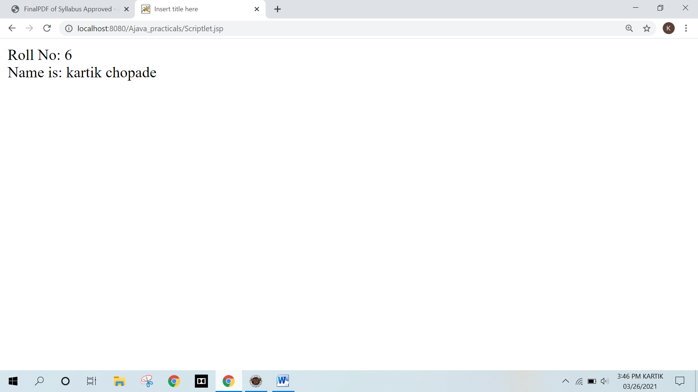

**C) Directives**

**ErrorDirective.jsp**

<%@ page language="java" contentType="text/html; charset=ISO-8859-1"

pageEncoding="ISO-8859-1"%>

<!DOCTYPE html>

<html>

<head>

<meta charset="ISO-8859-1">

<title>Insert title here</title>

</head>

<body>

<%@ page errorPage="Errorpage.jsp" %>

<%= 100/0 %>

</body>

</html>

**Errorpage.jsp**

<%@ page language="java" contentType="text/html; charset=ISO-8859-1"

pageEncoding="ISO-8859-1"%>

<!DOCTYPE html>

<html>

<head>

<meta charset="ISO-8859-1">

<title>Insert title here</title>

</head>

<body>

<%

out.println("Something went Wrong");

%>

</body>

</html>

**Output :**

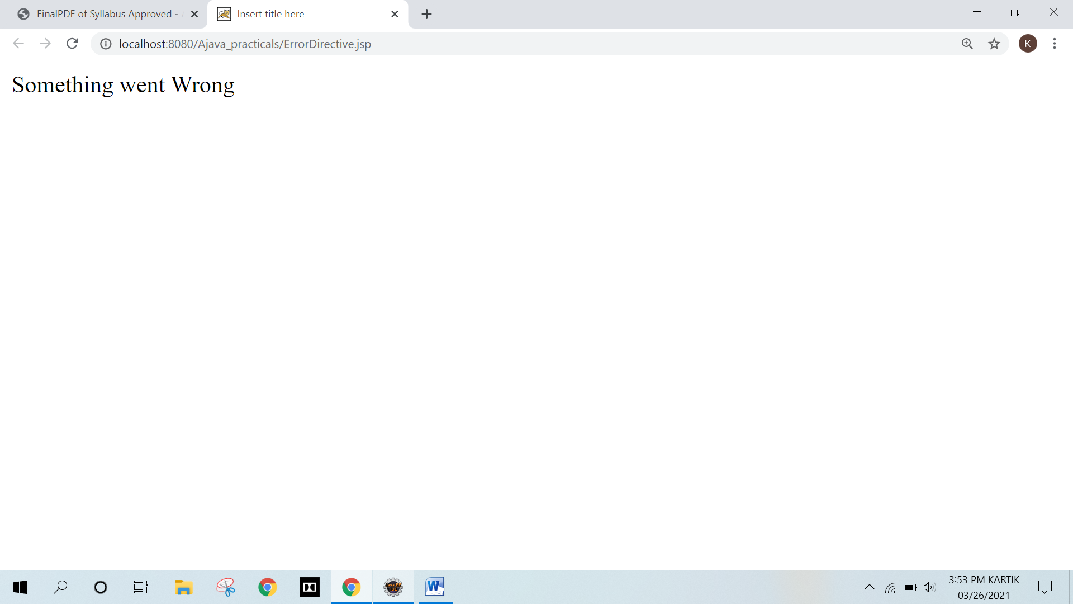

**D) Expression**

**Design.html**

<!DOCTYPE html>

<html>

<head>

<meta charset="ISO-8859-1">

<title>Insert title here</title>

</head>

<body>

<form action="Expressiontag.jsp" method="post">

<br><br><br>

<table border="1" align="center">

<tr>

<td>Enter Roll No: </td>

<td><input type="text" name="r"></td>

</tr>

<tr>

<td>Enter Student Name: </td>

<td><input type="text" name="n"></td>

</tr>

<tr>

<td colspan="2" align="center"><input type="submit" value="Submit" name="sub"></td>

</tr>

</table>

</form>

<a href="select.jsp">view all data</a>

</body>

</html>

**Expressiontag.jsp**

<%@ page language="java" contentType="text/html; charset=ISO-8859-1"

pageEncoding="ISO-8859-1"%>

<!DOCTYPE html>

<html>

<head>

<meta charset="ISO-8859-1">

<title>Insert title here</title>

</head>

<body>

<%= "Roll No: "+request.getParameter("r") %>

<% out.println("<br>");%>

<%= "Name is: "+request.getParameter("n") %>

</body>

</html>

**Output :**

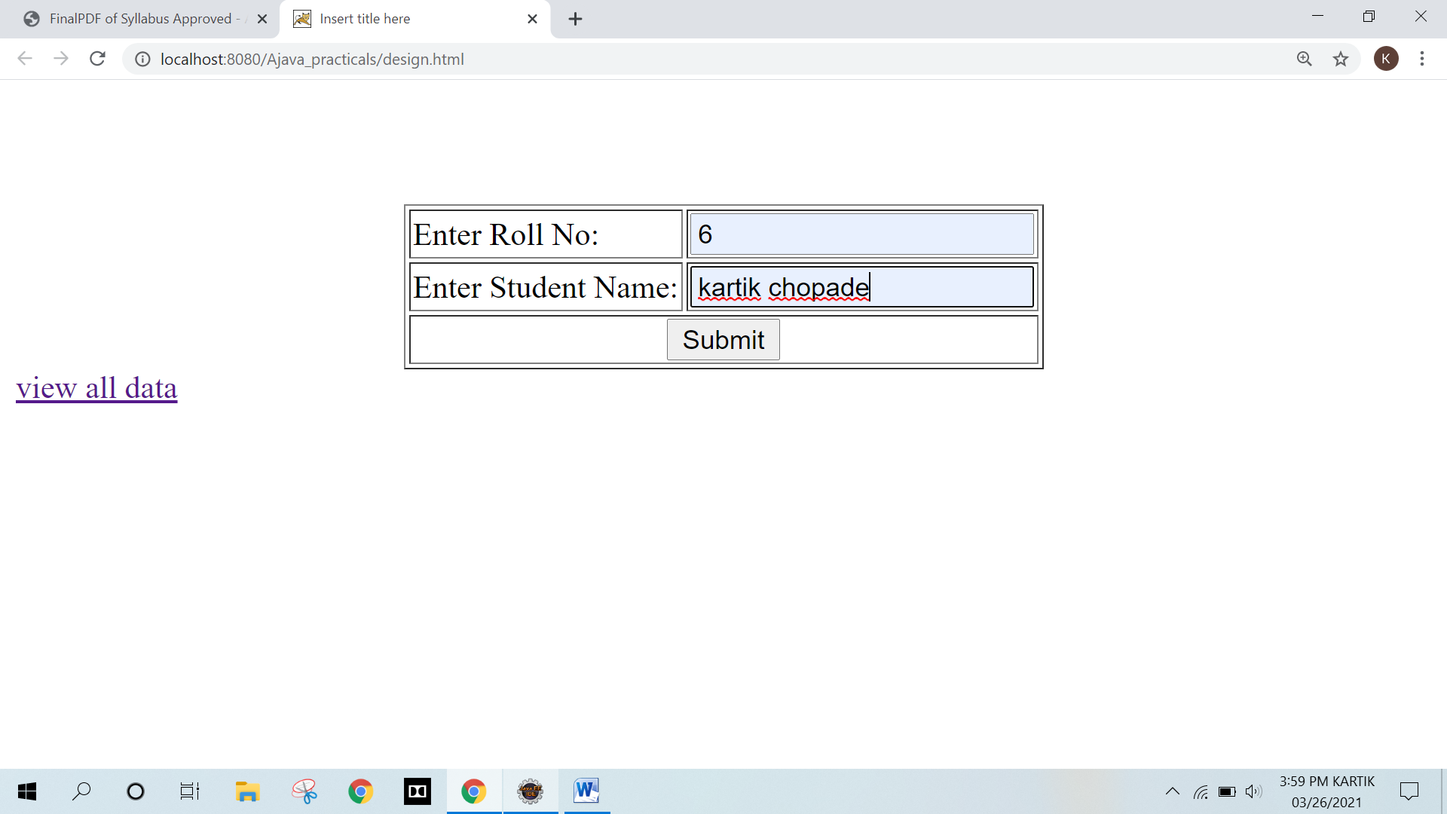

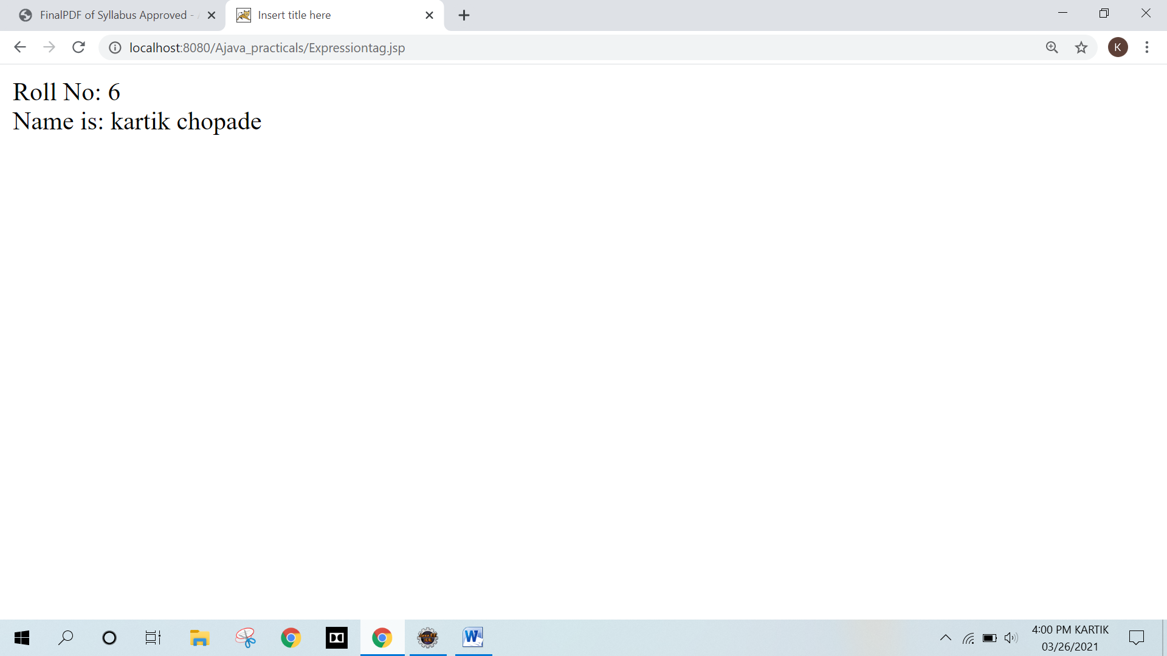

**Q.2 Write a JSP program to add, delete and display the records from StudentMaster (RollNo, Name, Semester, Course) table.**

**A) ADD**

<!DOCTYPE html>

<html>

<head>

<meta charset="ISO-8859-1">

<title>Insert title here</title>

</head>

<body>

<form action="Insert.jsp" method="post">

<br><br><br>

<table border="1" align="center">

<tr>

<td>Enter Roll No: </td>

<td><input type="text" name="roll"></td>

</tr>

<tr>

<td>Enter Student Name: </td>

<td><input type="text" name="name"></td>

</tr>

<tr>

<td>Enter Student Semester: </td>

<td><input type="text" name="semester"></td>

</tr>

<tr>

<td>Enter Student Course: </td>

<td><input type="text" name="course"></td>

</tr>

<tr>

<td colspan="2" align="center"><input type="submit" value="Submit"></td>

</tr>

</table>

</form>

</body>

</html>

**Insert.jsp**

<%@page import="java.sql.*"%>

<%@ page language="java" contentType="text/html; charset=ISO-8859-1"

pageEncoding="ISO-8859-1"%>

<!DOCTYPE html>

<html>

<head>

<meta charset="ISO-8859-1">

<title>Insert title here</title>

</head>

<body>

<%

int roll=Integer.parseInt(request.getParameter("roll"));

String name=request.getParameter("name");

String semester=request.getParameter("semester");

String course=request.getParameter("course");

try

{

Class.forName("com.mysql.jdbc.Driver");

Connection con = DriverManager.getConnection("jdbc:mysql://localhost:3306/kartik","root","");

Statement stmt=con.createStatement();

String sql="insert into studentmaster values("+roll+",'"+name+"','"+semester+"','"+course+"')";

stmt.executeUpdate(sql);

con.close();

out.println("data inserted sucessfully");

}

catch(Exception ex)

{

out.println("something wrong");

}

%>

</body>

</html>

**Output :**

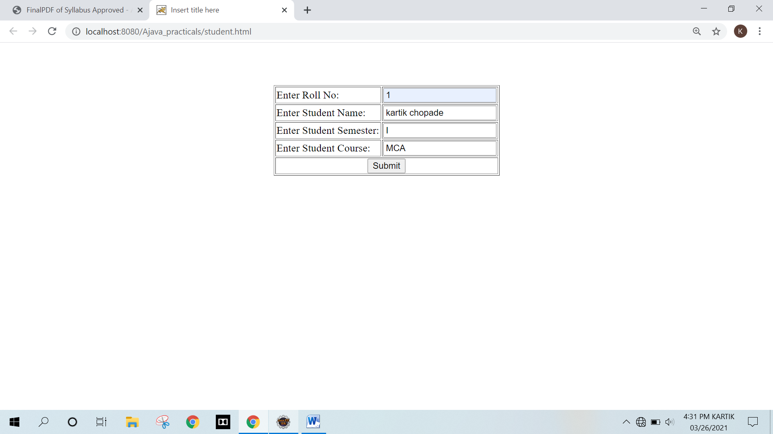

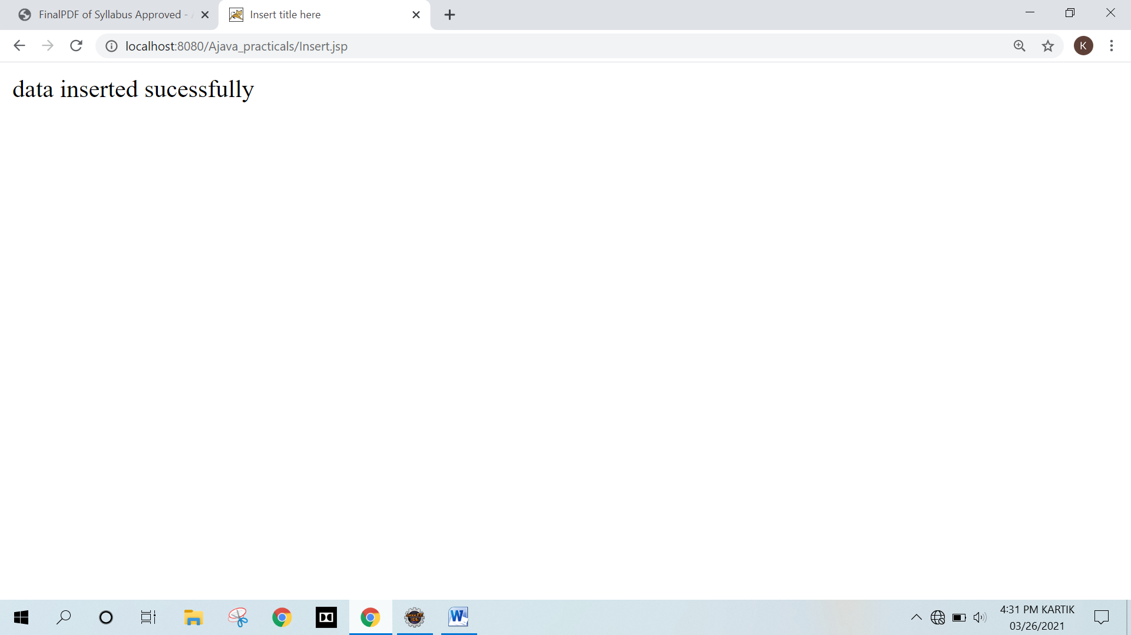

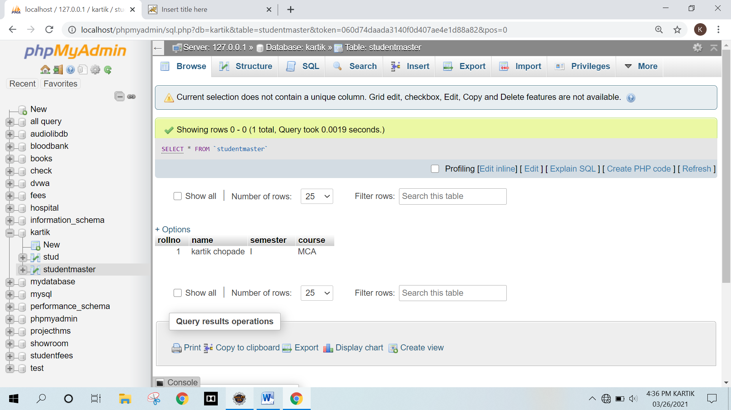

**B) Display**

**Select.jsp**

<%@page import="java.sql.*" %>

<%@ page language="java" contentType="text/html; charset=ISO-8859-1"

pageEncoding="ISO-8859-1"%>

<!DOCTYPE html>

<html>

<head>

<meta charset="ISO-8859-1">

<title>Insert title here</title>

</head>

<body>

<%

try

{

Class.forName("com.mysql.jdbc.Driver");

Connectioncon =

DriverManager.getConnection("jdbc:mysql://localhost:3306/kartik","root","");

Statement stmt=con.createStatement();

String sql="select * from studentmaster";

ResultSet rs=stmt.executeQuery(sql);

while(rs.next())

{

out.println("<center>");

out.println("ID: "+rs.getInt(1));

out.println("<br>");

out.println("Name: "+rs.getString(2));

out.println("<br>");

out.println("Semester: "+rs.getString(3));

out.println("<br>");

out.println("Course: "+rs.getString(4));

out.println("</center>");

}

con.close();

}

catch(Exception ex)

{

out.println("Something went wrong");

}

%>

</body>

</html>

**Output :**

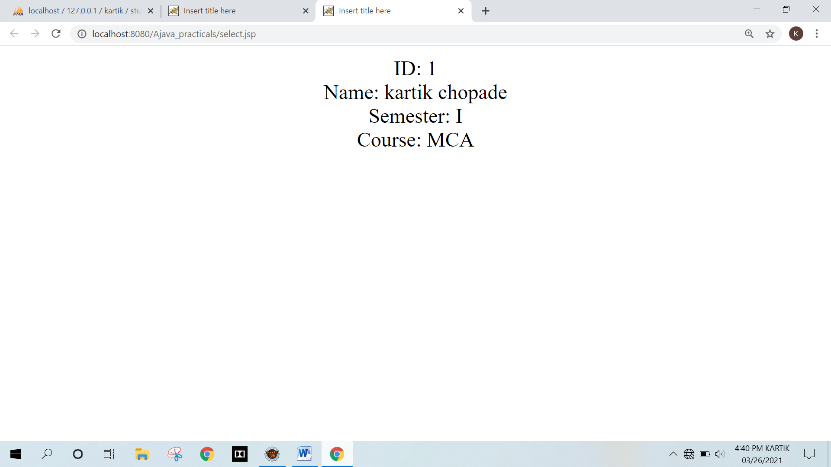

**C) Delete**

**Student.html**

<!DOCTYPE html>

<html>

<head>

<meta charset="ISO-8859-1">

<title>Insert title here</title>

</head>

<body>

<form action="Delete.jsp" method="post">

<br><br><br>

<table border="1" align="center">

<tr>

<td>Enter Roll No: </td>

<td><input type="text" name="roll"></td>

</tr>

<tr>

<td>Enter Student Name: </td>

<td><input type="text" name="name"></td>

</tr>

<tr>

<td>Enter Student Semester: </td>

<td><input type="text" name="semester"></td>

</tr>

<tr>

<td>Enter Student Course: </td>

<td><input type="text" name="course"></td>

</tr>

<tr>

<td colspan="2" align="center"><input type="submit" value="Submit"></td>

</tr>

</table>

</form>

</body>

</html>

**Delete.jsp**

<%@page import="java.sql.*" %>

<%@ page language="java" contentType="text/html; charset=ISO-8859-1"

pageEncoding="ISO-8859-1"%>

<!DOCTYPE html>

<html>

<head>

<meta charset="ISO-8859-1">

<title>Insert title here</title>

</head>

<body>

<%

try

{

int roll=Integer.parseInt(request.getParameter("roll"));

Class.forName("com.mysql.jdbc.Driver");

Connection con =

DriverManager.getConnection("jdbc:mysql://localhost:3306/kartik","root","");

Statement stmt=con.createStatement();

String sql="delete from studentmaster where rollno="+roll+"";

stmt.executeUpdate(sql);

con.close();

out.println("Data deleted sucessfully");

}

catch(Exception ex)

{

out.println("some thing went wrong");

}

%>

</body>

</html>

**Output :**

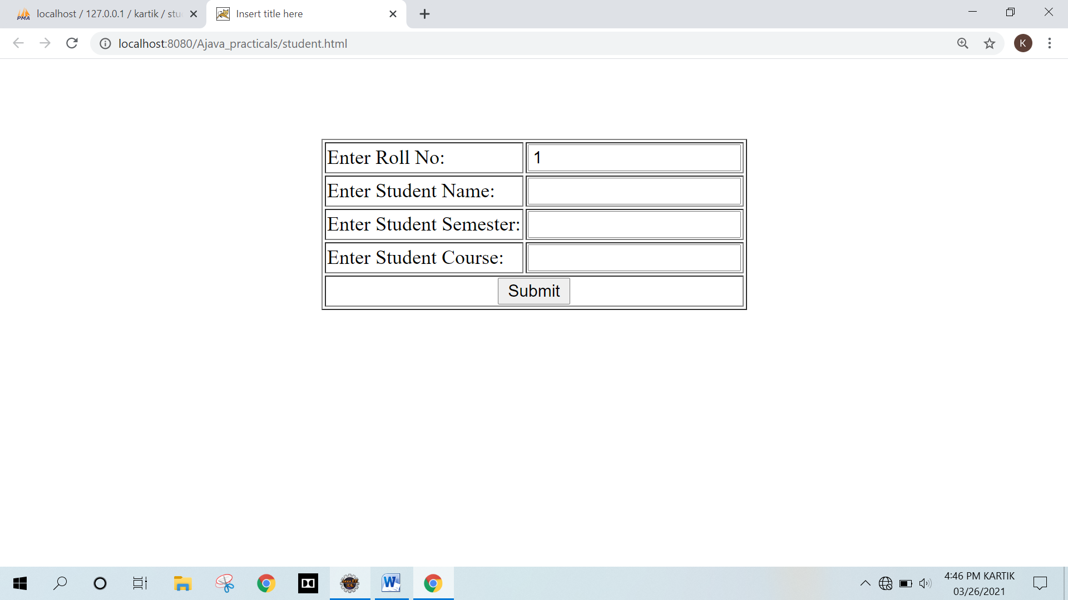

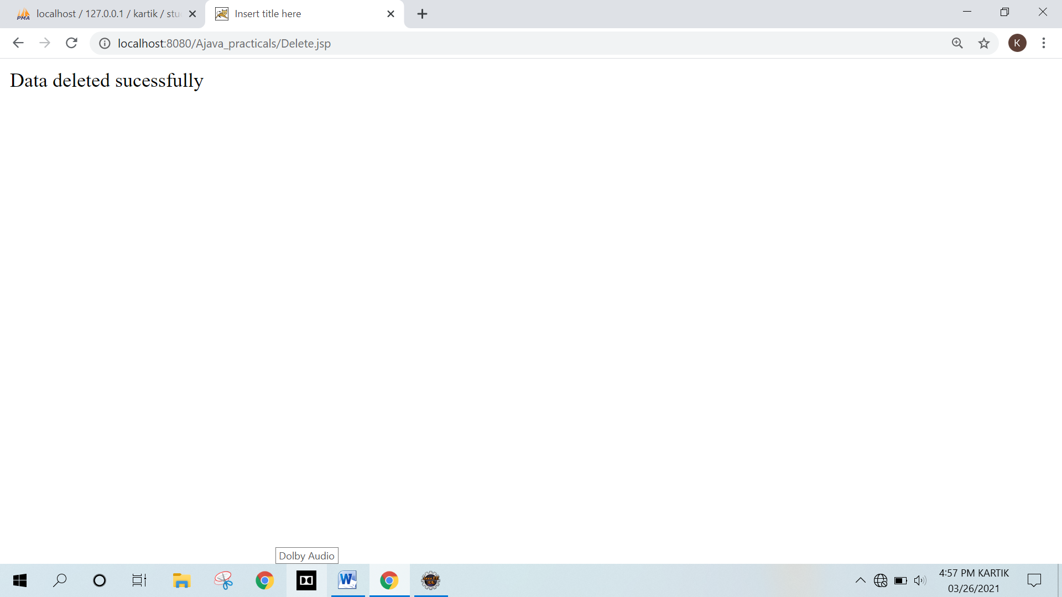

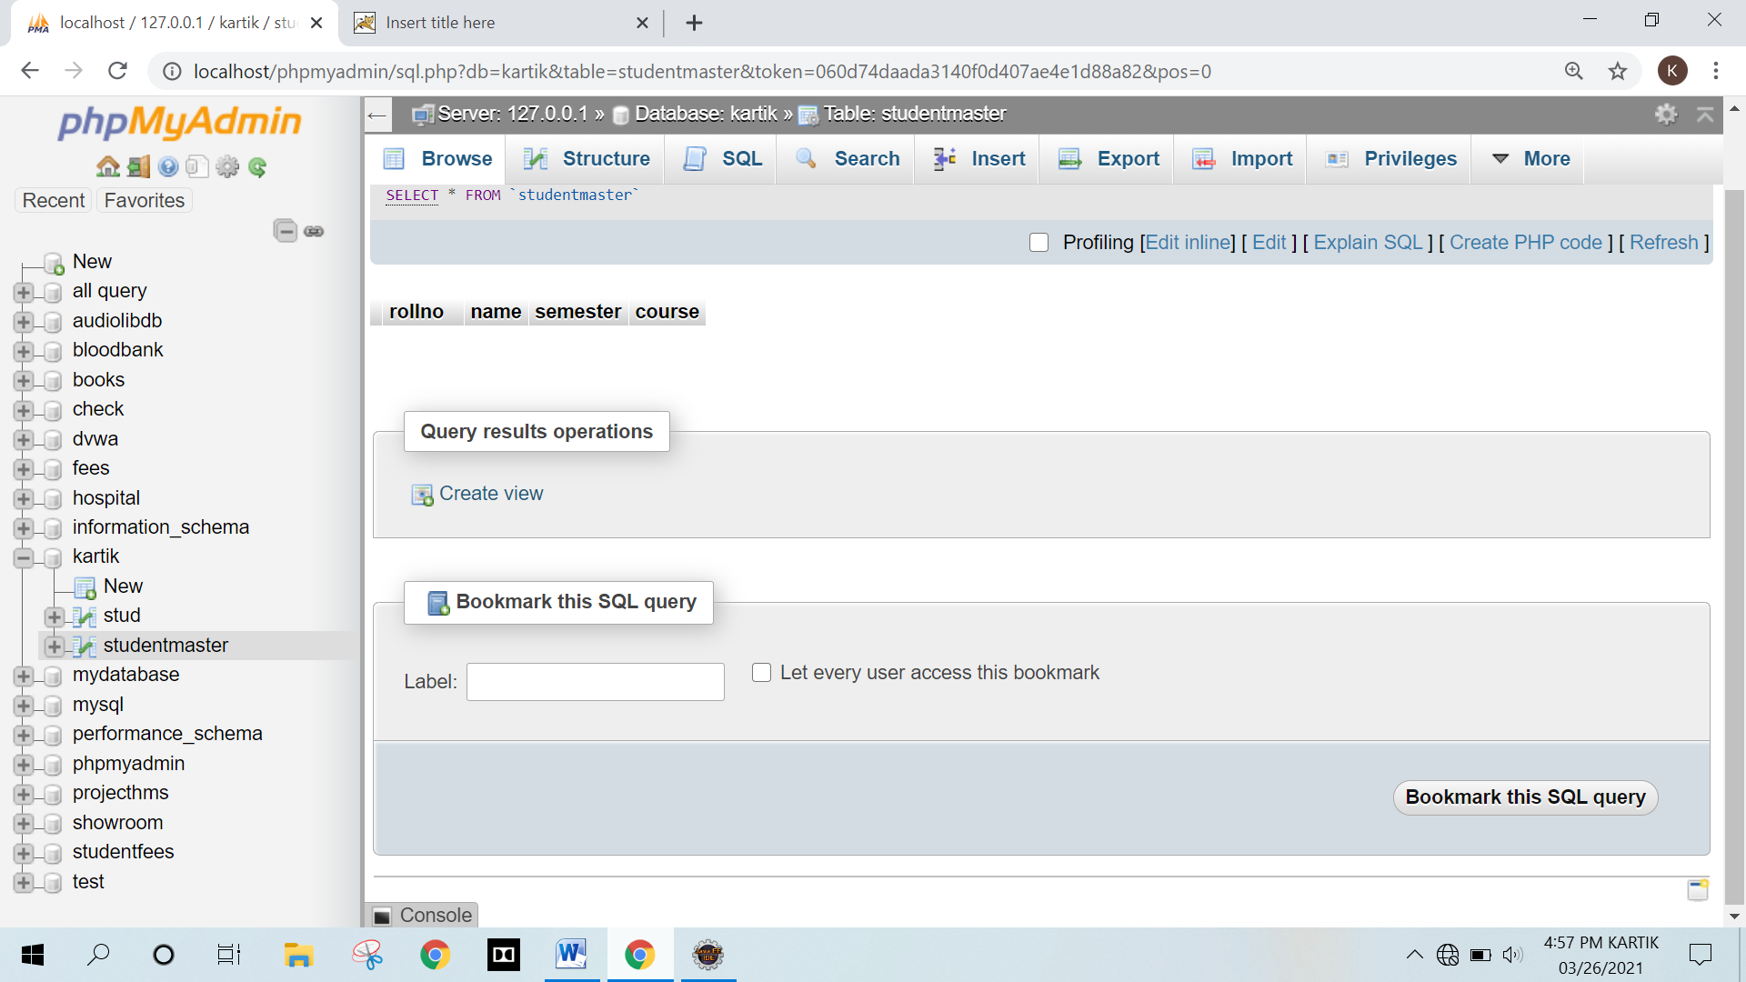

**Q.3) Write a JSP program that demonstrates the use of JSP ActionTags.**

**A) Forward**

**Actionforword.jsp**

<%@ page language="java" contentType="text/html; charset=ISO-8859-1"

pageEncoding="ISO-8859-1"%>

<!DOCTYPE html>

<html>

<head>

<meta charset="ISO-8859-1">

<title>Insert title here</title>

</head>

<body>

<jsp:forward page="Printdate.jsp" />

</body>

</html>

**Printdate.jsp**

<%@ page language="java" contentType="text/html; charset=ISO-8859-1"

pageEncoding="ISO-8859-1"%>

<!DOCTYPE html>

<html>

<head>

<meta charset="ISO-8859-1">

<title>Insert title here</title>

</head>

<body>

<% out.print("Today is:"+java.util.Calendar.getInstance().getTime()); %>

</body>

</html>

**Output :**

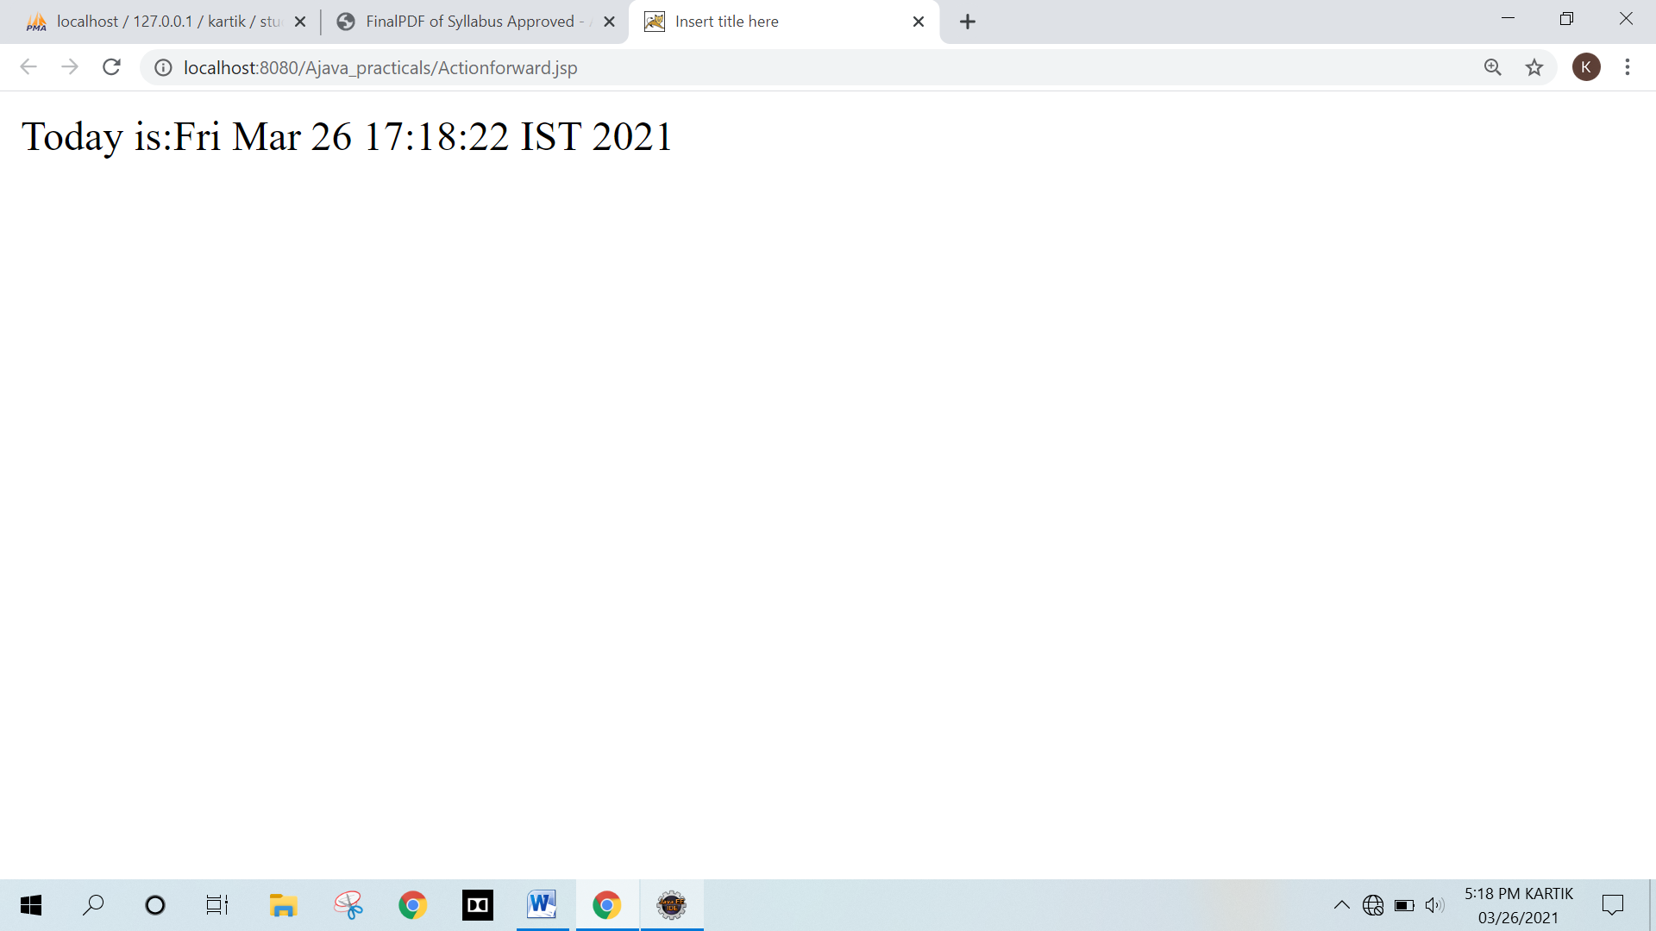

**B) Forward Action With Parameter**

**Actionforward1.jsp**

<%@ page language="java" contentType="text/html; charset=ISO-8859-1"

pageEncoding="ISO-8859-1"%>

<!DOCTYPE html>

<html>

<head>

<meta charset="ISO-8859-1">

<title>Insert title here</title>

</head>

<body>

<jsp:forward page="Printdate.jsp" >

<jsp:param name="name" value="Kartik Chopade Roll No: 6" />

</jsp:forward>

</body>

</html>

**Printdate.jsp**

<%@ page language="java" contentType="text/html; charset=ISO-8859-1"

pageEncoding="ISO-8859-1"%>

<!DOCTYPE html>

<html>

<head>

<meta charset="ISO-8859-1">

<title>Insert title here</title>

</head>

<body>

<% out.print("Today is:"+java.util.Calendar.getInstance().getTime()); %>

<%out.println("<br>");%>

<%= request.getParameter("name") %>

</body>

</html>

**Output :**

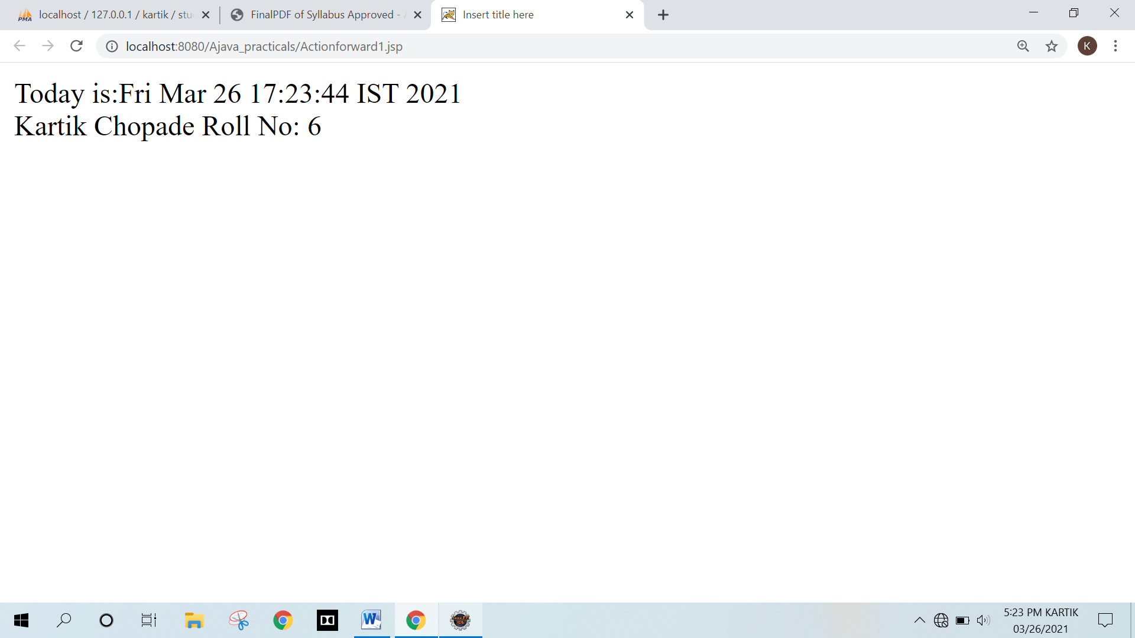

**C) ActtionInclude**

**Actioninclude.jsp**

<%@ page language="java" contentType="text/html; charset=ISO-8859-1"

pageEncoding="ISO-8859-1"%>

<!DOCTYPE html>

<html>

<head>

<meta charset="ISO-8859-1">

<title>Insert title here</title>

</head>

<body>

<jsp:include page="Printdate.jsp" />

</body>

</html>

**Printdate.jsp**

<%@ page language="java" contentType="text/html; charset=ISO-8859-1"

pageEncoding="ISO-8859-1"%>

<!DOCTYPE html>

<html>

<head>

<meta charset="ISO-8859-1">

<title>Insert title here</title>

</head>

<body>

<% out.print("Today is:"+java.util.Calendar.getInstance().getTime()); %>

</body>

</html>

**Output :**

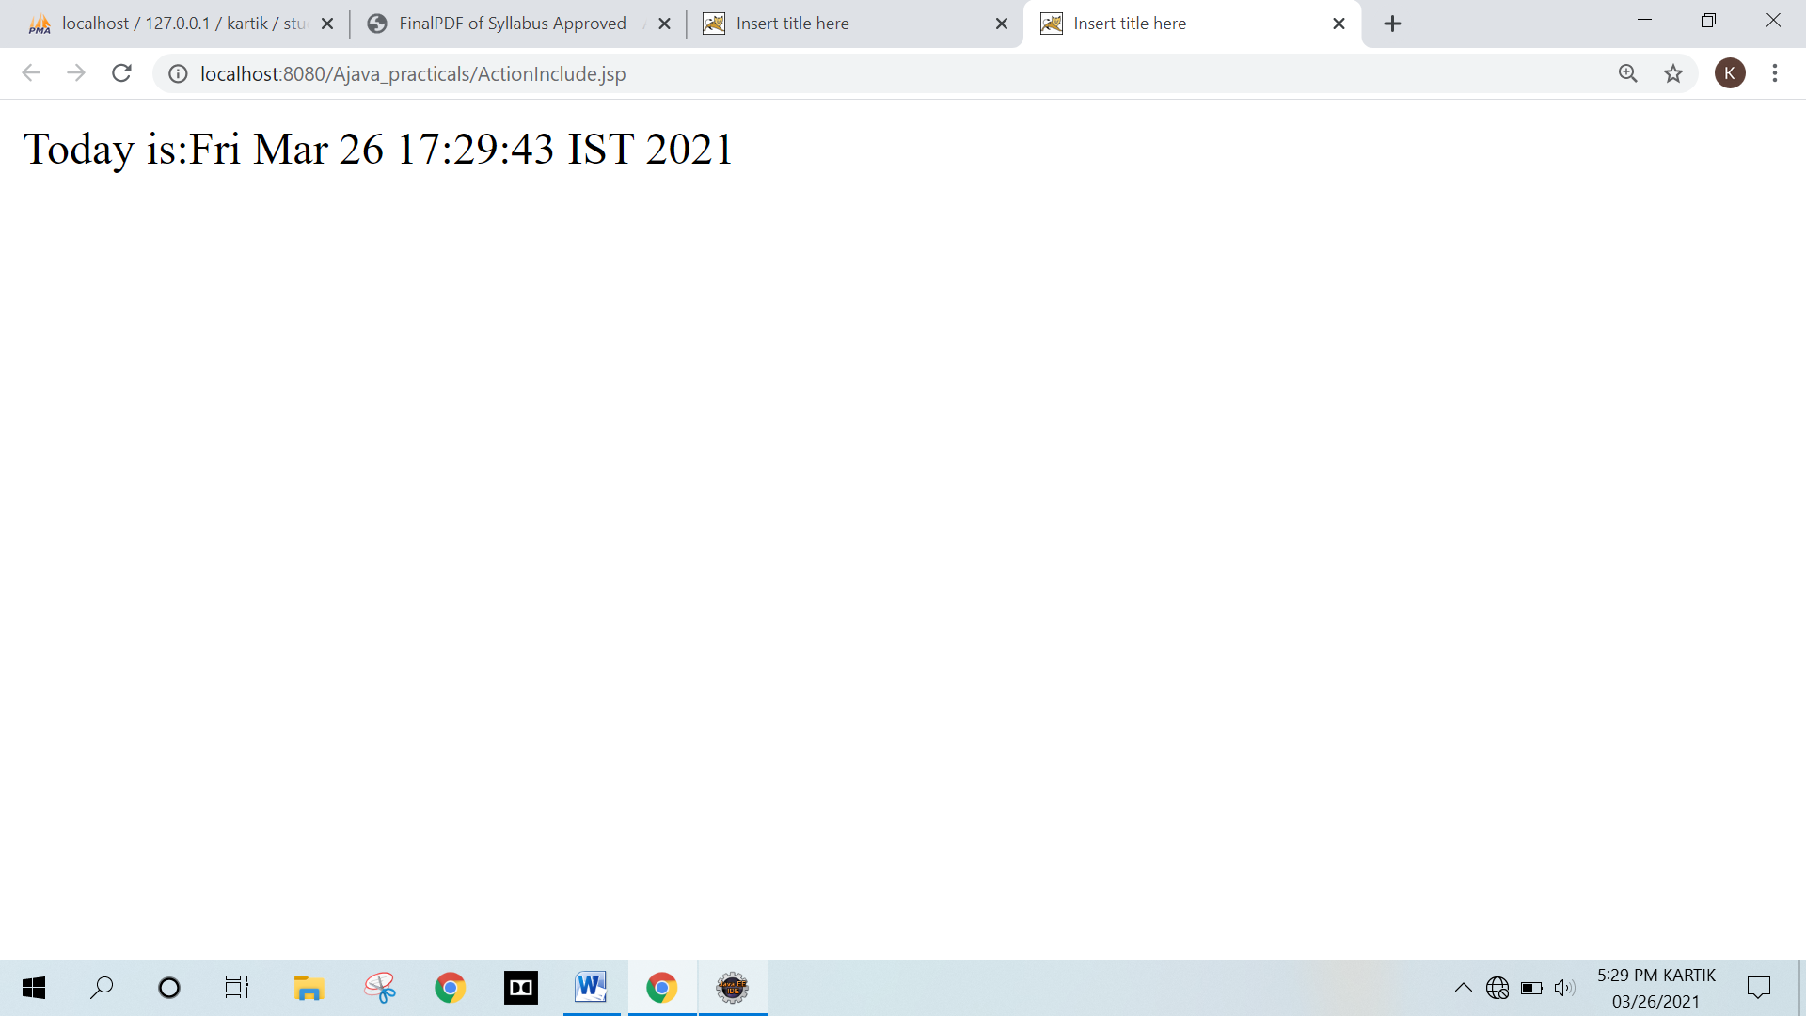

**D) ActionBean**

**Calculater.java**

package com.kartik;

public class Calculator

{

public int cube(int n)

{

return n*n*n;

}

}

**Actionbean.jsp**

<%@ page language="java" contentType="text/html; charset=ISO-8859-1"

pageEncoding="ISO-8859-1"%>

<!DOCTYPE html>

<html>

<head>

<meta charset="ISO-8859-1">

<title>Insert title here</title>

</head>

<body>

<jsp:useBean id="obj" class="com.kartik.Calculator"/>

<%

int m=obj.cube(5);

out.print("cube of 5 is "+m);

%>

</body>

</html>

**Output :**

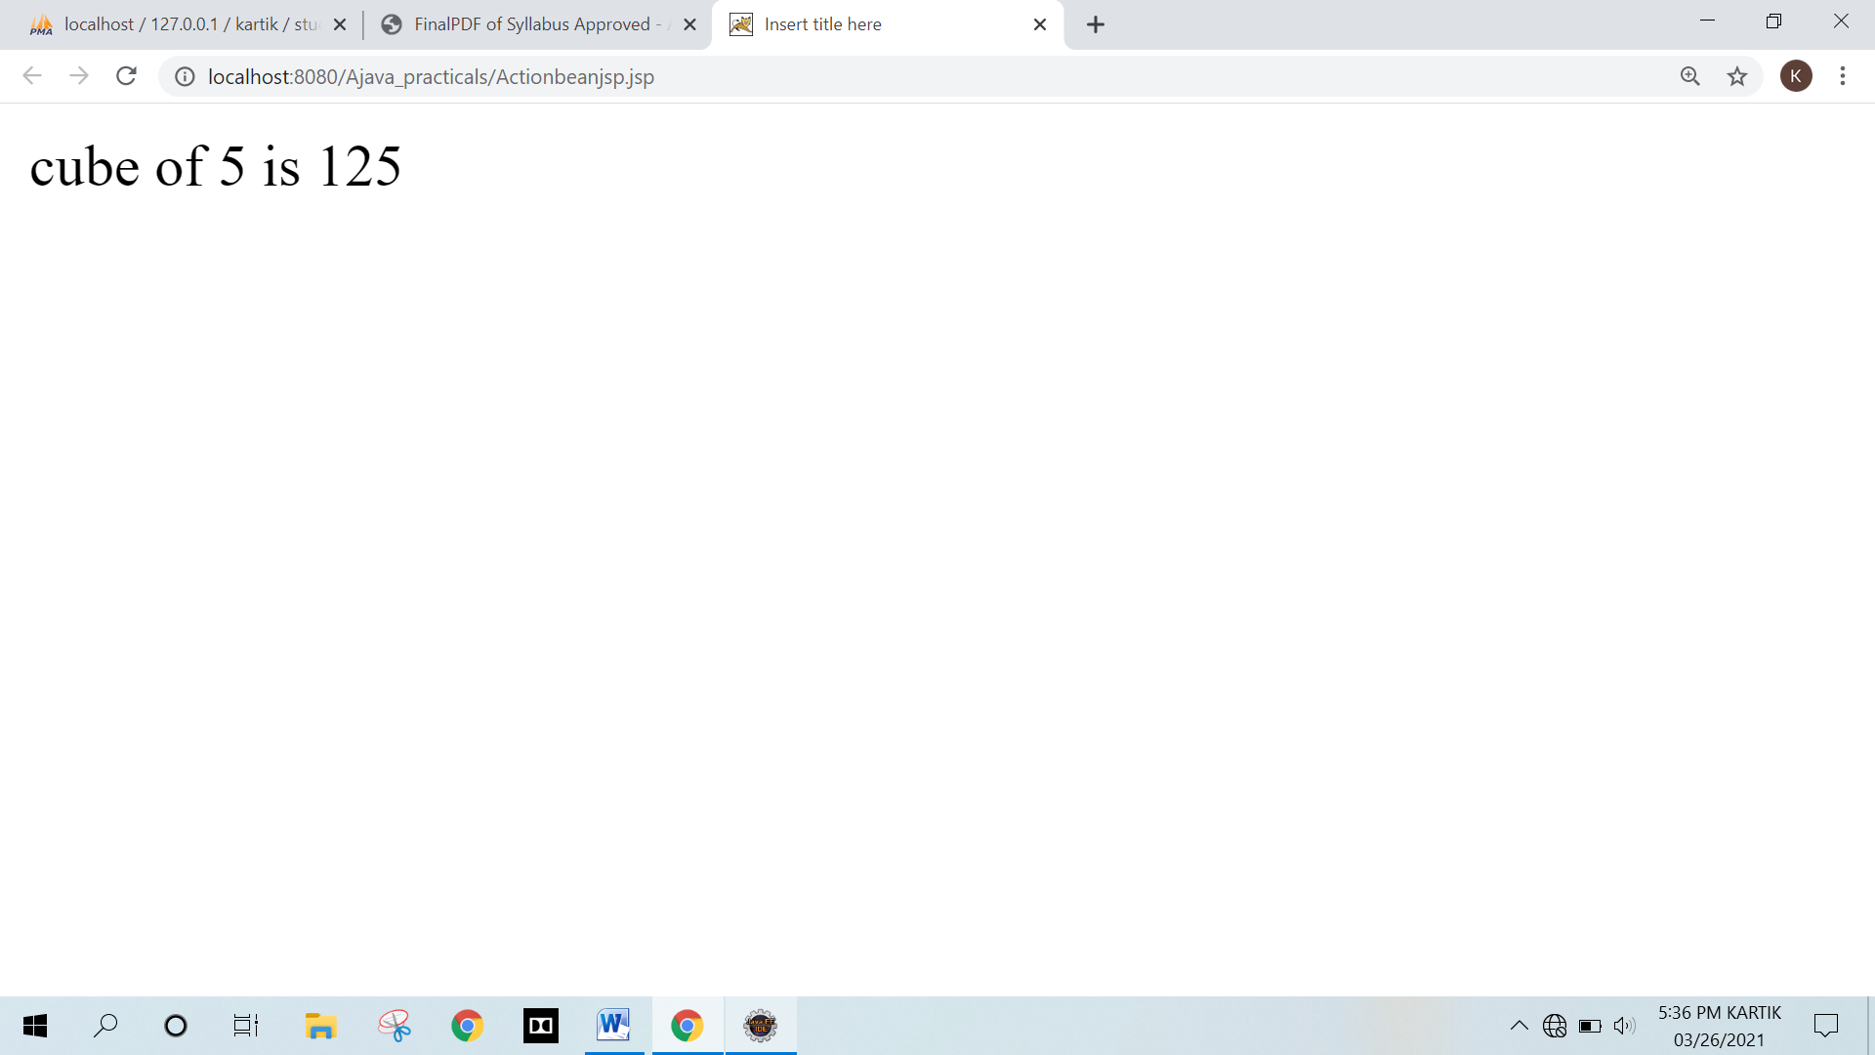

**EXPERIMENT NO. 7**

**ASSIGNMENT BASED SPRING FRAMEWORK**

**EXPERIMENT NO. 7**

**ASSIGNMENT BASED SPRING FRAMEWORK**

**Q.1 Write a program to print “Hello World” using spring framework.**

**Program :**

**Hello.java**

package com.kartik;

public class Hello

{

String mg;

int i;

public String getMg()

{

return mg;

}

public void setMg(String mg)

{

this.mg = mg;

}

public int getI()

{

return i;

}

public void setI(int i)

{

this.i = i;

}

public void show()

{

for(int j=1;j<=i;j++)

{

System.out.println(mg);

}

}

}

**Mainapp.java**

package com.kartik;

import org.springframework.context.ApplicationContext;

import org.springframework.context.support.ClassPathXmlApplicationContext;

public class Mainapp

{

public static void main(String[] args)

{

ApplicationContext context =

new ClassPathXmlApplicationContext("com/kartik/Kartik.xml");

Hello obj = (Hello)context.getBean("Hello");

obj.show();

}

}

**Kartik.xml**

<?xml version="1.0" encoding="UTF-8"?>

<beans xmlns = "http://www.springframework.org/schema/beans"

xmlns:xsi = "http://www.w3.org/2001/XMLSchema-instance"

xsi:schemaLocation = "http://www.springframework.org/schema/beans

http://www.springframework.org/schema/beans/spring-beans-3.0.xsd">

<bean id = "Hello" class = "com.kartik.Hello">

<property name = "mg" value = "Kartik chopade"/>

<property name = "i" value = "5"/>

</bean>

</beans>

**Output :**

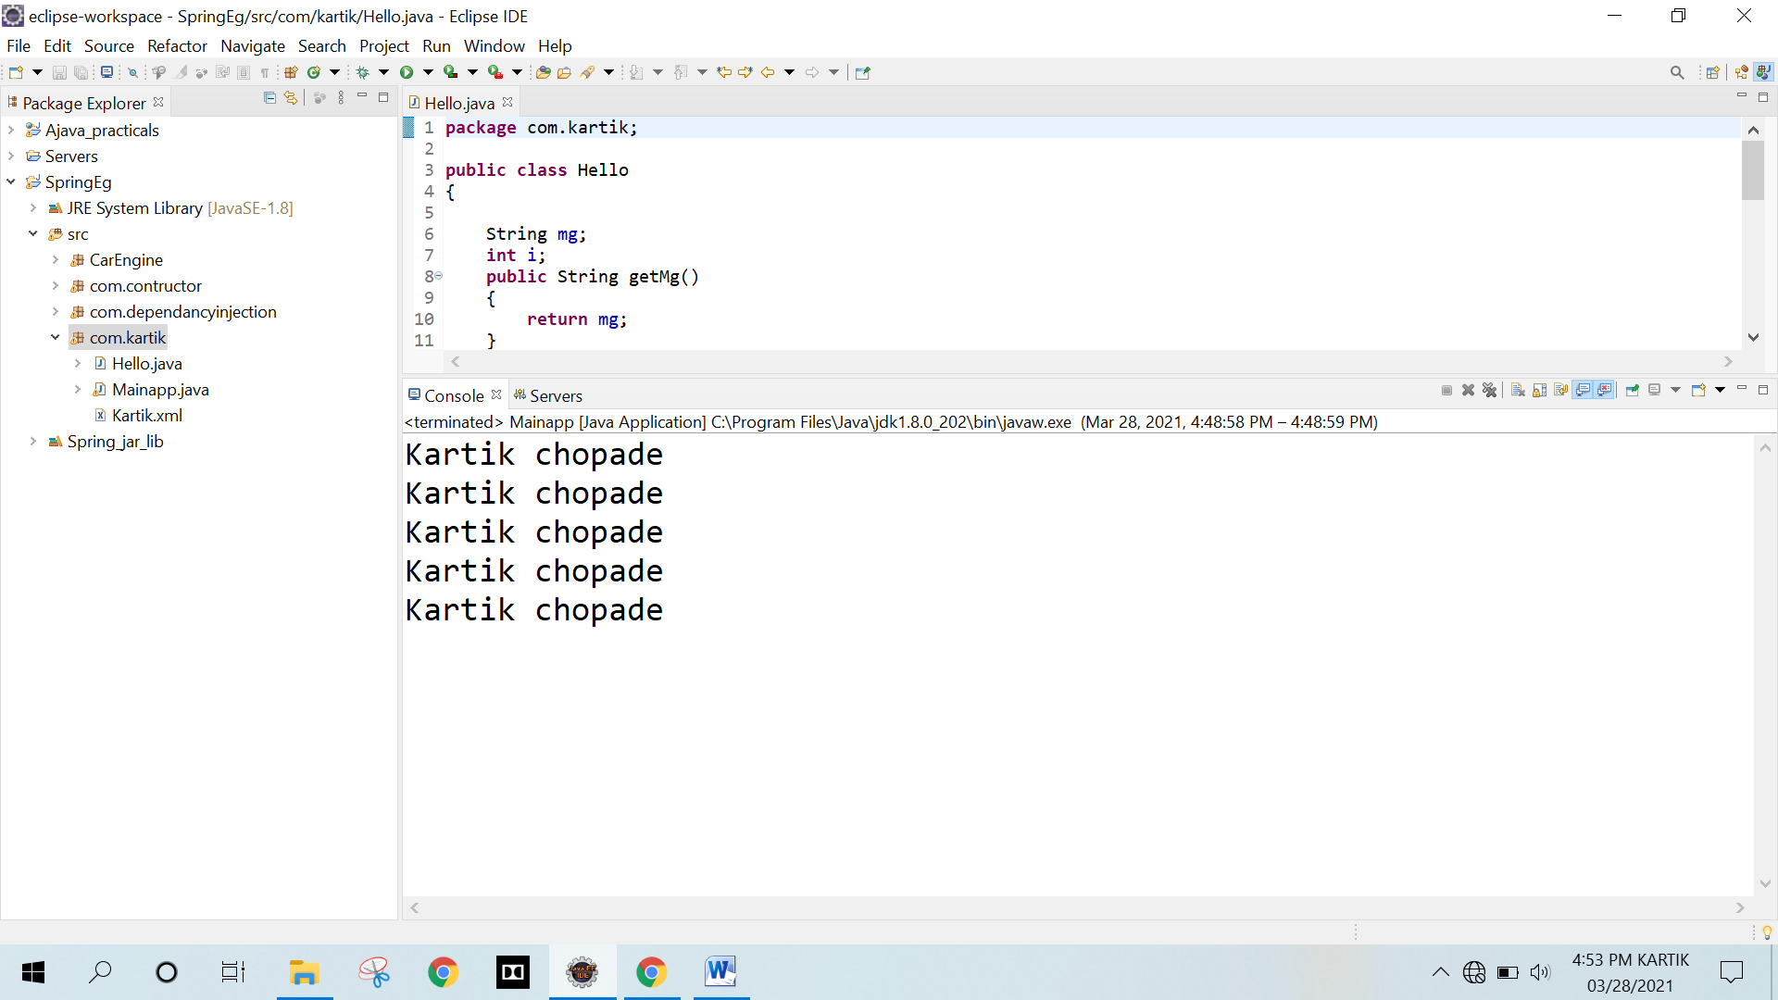

**Q.2 Write a program to demonstrate dependency injection via setter method.**

**A) WAP using spring to display tables of a number**

**Program :**

**Employee.java**

package com.dependancyinjection;

public class Employee

{

private int tableTill;

private int tableOfNumber;

public int getTableTill()

{

return tableTill;

}

public void setTableTill(int tableTill)

{

this.tableTill = tableTill;

}

public int getTableOfNumber()

{

return tableOfNumber;

}

public void setTableOfNumber(int tableOfNumber)

{

this.tableOfNumber = tableOfNumber;

}

public void displayTable()

{

System.out.println("Your table is displayed below :-");

for (int i = 1; i <= tableTill; i++)

{

System.out.println(tableOfNumber + " * " + i + " = " + tableOfNumber*i);

}

}

}

**Test.java**

package com.dependancyinjection;

import org.springframework.context.ApplicationContext;

import org.springframework.context.support.ClassPathXmlApplicationContext;

public class Test

{

public static void main(String[] args)

{

ApplicationContext context = new ClassPathXmlApplicationContext("com/dependancyinjection/injection.xml");

Employee obj = (Employee)context.getBean("table");

Employee obj2 = (Employee)context.getBean("table2");

obj.displayTable();

obj2.displayTable();

}

}

**injection.xml**

<?xml version = "1.0" encoding = "UTF-8"?>

<beans xmlns = "http://www.springframework.org/schema/beans"

xmlns:xsi = "http://www.w3.org/2001/XMLSchema-instance"

xsi:schemaLocation = "http://www.springframework.org/schema/beans

http://www.springframework.org/schema/beans/spring-beans-3.0.xsd">

<bean id = "table" class = "com.dependancyinjection.Employee">

<property name = "tableOfNumber" value = "2"/>

<property name = "tableTill" value = "10"/>

</bean>

<bean id = "table2" class = "com.dependancyinjection.Employee">

<property name = "tableOfNumber" value = "5"/>

<property name = "tableTill" value = "10"/>

</bean>

</beans>

**Output :**

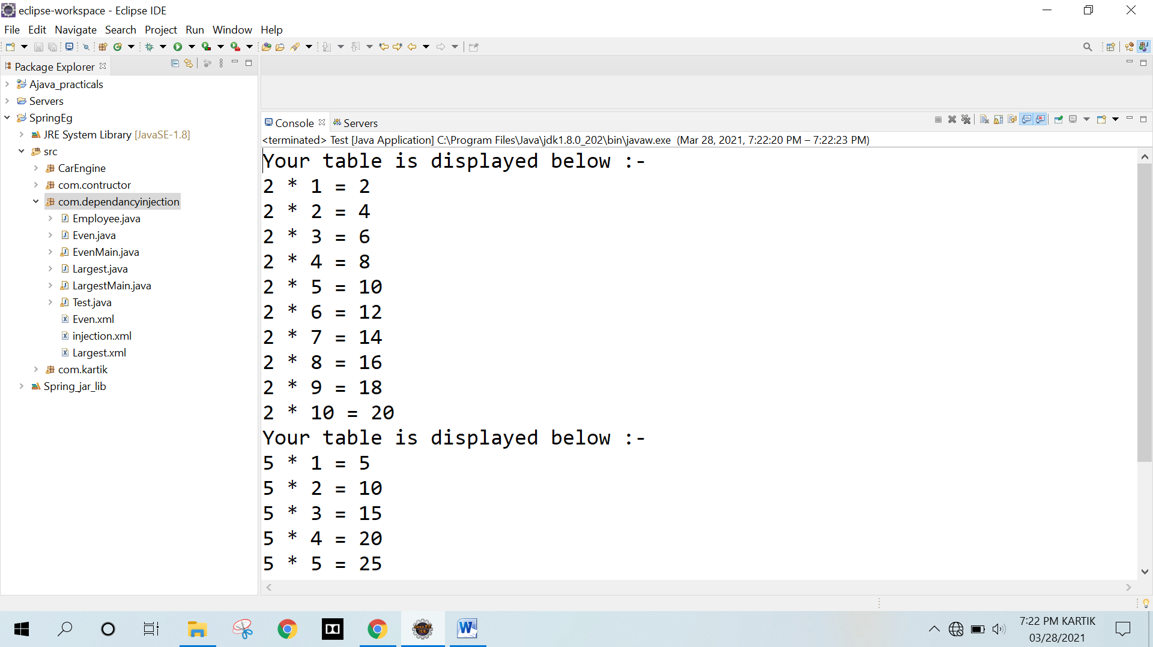

**B) WAP using spring to display even numbers between two accepted numbers.**

**Even.java**

package com.dependancyinjection;

public class Even

{

private int startNum;

private int endNum;

public int getStartNum()

{

return startNum;

}

public void setStartNum(int startNum)

{

this.startNum = startNum;

}

public int getEndNum()

{

return endNum;

}

public void setEndNum(int endNum)

{

this.endNum = endNum;

}

public void displayData()

{

System.out.println("\nEven number between " + startNum + " to " + endNum + " are : ");

for (int i = startNum; i <= endNum; i++)

{

System.out.print((i%2 == 0) ? (i + " ") : "");

}

}

}

**EvenMain.java**

package com.dependancyinjection;

import org.springframework.context.ApplicationContext;

import org.springframework.context.support.ClassPathXmlApplicationContext;

public class EvenMain

{

public static void main(String[] args)

{

ApplicationContext context = new ClassPathXmlApplicationContext("com/dependancyinjection/Even.xml");

Even obj = (Even)context.getBean("numStorage");

Even obj2 = (Even)context.getBean("numStorage2");

obj.displayData();

obj2.displayData();

}

}

**Even.xml**

<?xml version="1.0" encoding="UTF-8"?>

<beans xmlns = "http://www.springframework.org/schema/beans"

xmlns:xsi = "http://www.w3.org/2001/XMLSchema-instance"

xsi:schemaLocation = "http://www.springframework.org/schema/beans

http://www.springframework.org/schema/beans/spring-beans-3.0.xsd">

<bean id = "numStorage" class = "com.dependancyinjection.Even">

<property name = "startNum" value = "3"/>

<property name = "endNum" value = "30"/>

</bean>

<bean id = "numStorage2" class = "com.dependancyinjection.Even">

<property name = "startNum" value = "60"/>

<property name = "endNum" value = "70"/>

</bean>

</beans>

**Output:**

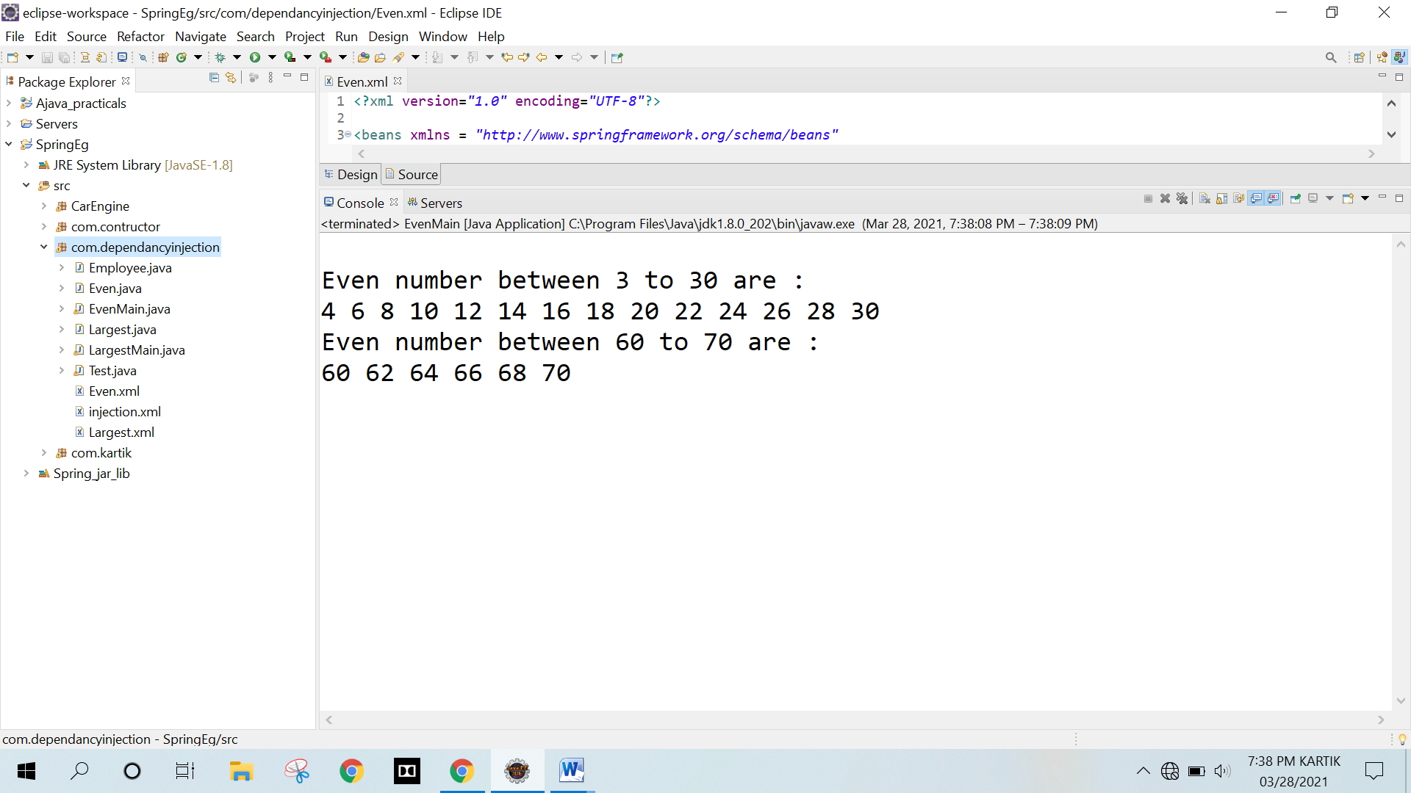

**C) WAP using spring to find largest amongst three numbers.**

**Program:**

**Largest.java**

package com.dependancyinjection;

public class Largest

{

private int firstNum;

private int secondNum;

private int thirdNum;

public int getFirstNum()

{

return firstNum;

}

public void setFirstNum(int firstNum)

{

this.firstNum = firstNum;

}

public int getSecondNum()

{

return secondNum;

}

public void setSecondNum(int secondNum)

{

this.secondNum = secondNum;

}

public int getThirdNum()

{

return thirdNum;

}

public void setThirdNum(int thirdNum)

{

this.thirdNum = thirdNum;

}

public int displayGreaterNumber()

{

System.out.println("Checking for " + firstNum + " " + secondNum + " " + thirdNum);

System.out.print("Highest Number is ");

if(firstNum == secondNum)

{

if(secondNum == thirdNum)

{

return firstNum;

}

}

else

{

if(firstNum < secondNum)

{

if(secondNum < thirdNum)

{

return thirdNum;

}

}

else

{

if(firstNum < thirdNum)

{

return thirdNum;

}

else

{

return firstNum;

}

}

}

return 404;

}

}

**LargestMain.java**

package com.dependancyinjection;

import org.springframework.context.ApplicationContext;

import org.springframework.context.support.ClassPathXmlApplicationContext;

public class LargestMain

{

public static void main(String[] args)

{

ApplicationContext context = new ClassPathXmlApplicationContext("com/dependancyinjection/Largest.xml");

Largest obj = (Largest)context.getBean("numStorage");

Largest obj2 = (Largest)context.getBean("numStorage2");

Largest obj3 = (Largest)context.getBean("numStorage3");

System.out.println(obj.displayGreaterNumber());

System.out.println(obj2.displayGreaterNumber());

System.out.println(obj3.displayGreaterNumber());

}

}

**Largest.xml**

<?xml version="1.0" encoding="UTF-8"?>

<beans xmlns = "http://www.springframework.org/schema/beans"

xmlns:xsi = "http://www.w3.org/2001/XMLSchema-instance"

xsi:schemaLocation = "http://www.springframework.org/schema/beans

http://www.springframework.org/schema/beans/spring-beans-3.0.xsd">

<bean id = "numStorage" class = "com.dependancyinjection.Largest">

<property name = "firstNum" value = "3"/>

<property name = "secondNum" value = "30"/>

<property name = "thirdNum" value = "60"/>

</bean>

<bean id = "numStorage2" class = "com.dependancyinjection.Largest">

<property name = "firstNum" value = "30"/>

<property name = "secondNum" value = "30"/>

<property name = "thirdNum" value = "30"/>

</bean>

<bean id = "numStorage3" class = "com.dependancyinjection.Largest">

<property name = "firstNum" value = "60"/>

<property name = "secondNum" value = "30"/>

<property name = "thirdNum" value = "10"/>

</bean>

</beans>

**Output :**

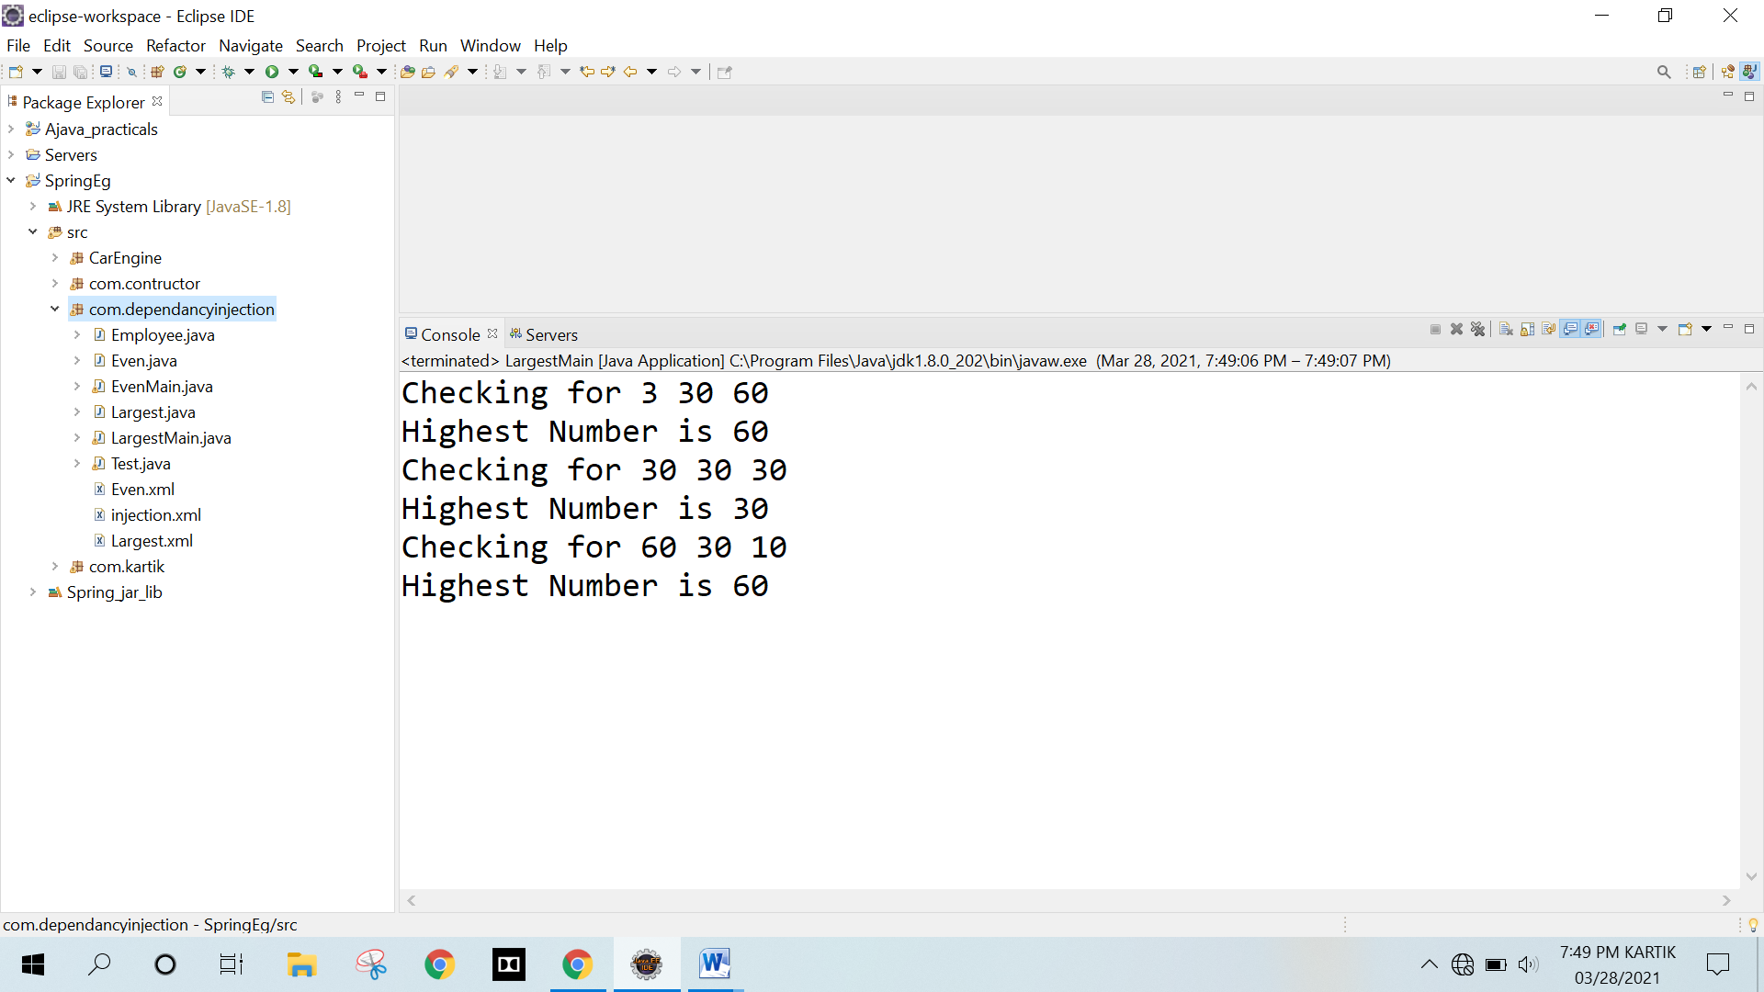

**Q.3 Write a program to demonstrate dependency injection via Constructor.**

**A) WAP using spring to check if a number is prime or not.**

**Program :**

**Prime.java**

**package** com.contructor;

public class Prime

{

private int number;

public Prime(int number)

{

this.number=number;

}

public boolean isPrime()

{

System.out.println("Checking if the number is Prime or not for : " + number);

for(int i = 2; i <= 100; i++)

{

if(number % i == 0)

{

return (number==i);

}

}

return false;

}

}

**PrimeMain.java**

package com.contructor;

import org.springframework.context.ApplicationContext;

import org.springframework.context.support.ClassPathXmlApplicationContext;

public class PrimeMain

{

public static void display(boolean check)

{

System.out.println((check) ? "The number is a Prime Number" : "The number is not a Prime Number");

}

public static void main(String[] args)

{

ApplicationContext context = new ClassPathXmlApplicationContext("com/contructor/Prime.xml");

Prime obj = (Prime)context.getBean("primeChecker");

Prime obj2 = (Prime)context.getBean("primeChecker2");

Prime obj3 = (Prime)context.getBean("primeChecker3");

display(obj.isPrime());

display(obj2.isPrime());

display(obj3.isPrime());

}

}

**Prime.xml**

<?xml version="1.0" encoding="UTF-8"?>

<beans xmlns = "http://www.springframework.org/schema/beans"

xmlns:xsi = "http://www.w3.org/2001/XMLSchema-instance"

xsi:schemaLocation = "http://www.springframework.org/schema/beans

http://www.springframework.org/schema/beans/spring-beans-3.0.xsd">

<bean id = "primeChecker" class = "com.contructor.Prime">

<constructor-arg value="3" type="int" />

</bean>

<bean id = "primeChecker2" class = "com.contructor.Prime">

<constructor-arg value="11" type="int" />

</bean>

<bean id = "primeChecker3" class = "com.contructor.Prime">

<constructor-arg value="20" type="int" />

</bean>

</beans>

**Output :**

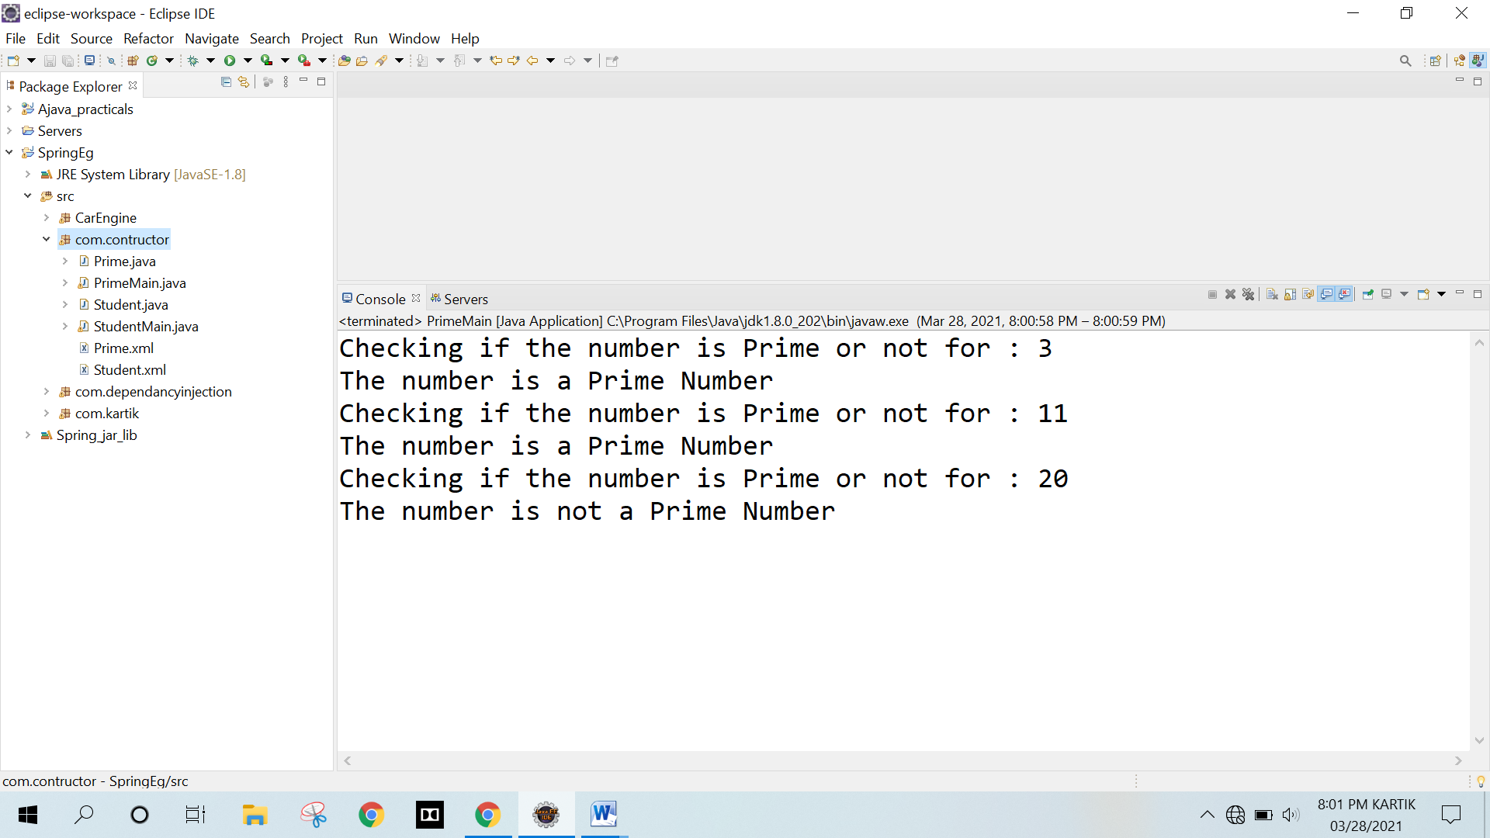

**B) WAP using spring to accept name, roll number and Grade of a student.**

* 1. **If grade = A then he/she is eligible for admission in engineering.**
  2. **If grade = B then he/she is eligible for admission in graduation.**
  3. **If grade = C then he/she is eligible for admission in diploma.**
  4. **If grade = anything else then he/she can pursue some skill based courses.**

**Program :**

**Student.java**

package com.contructor;

public class Student

{

private String name;

private int rollNo;

private String grade;

public Student(String name, int rollNo, String grade)

{

this.name = name;

this.rollNo = rollNo;

this.grade = grade;

}

public String getName()

{

return name;

}

public void setName(String name)

{

this.name = name;

}

public int getRollNo()

{

return rollNo;

}

public void setRollNo(int rollNo)

{

this.rollNo = rollNo;

}

public String getGrade()

{

return grade;

}

public void setGrade(String grade)

{

this.grade = grade;

}

public void display()

{

System.out.println("Name="+name+" Roll No="+rollNo+" Grade="+grade);

switch(grade)

{

case "A": System.out.println(name+" is eligible for admission in engineering");

break;

case "B": System.out.println(name+"is eligible for admission in graduation.");

break;

case "C": System.out.println(name+" is eligible for admission in diploma");

break;

default: System.out.println(name+" can pursue some skill based courses");

break;

}

}

}

**StudentMain.java**

package com.contructor;

import org.springframework.context.ApplicationContext;

import org.springframework.context.support.ClassPathXmlApplicationContext;

public class StudentMain

{

public static void main(String[] args)

{

ApplicationContext context = new ClassPathXmlApplicationContext("com/contructor/Student.xml");

Student stud = (Student) context.getBean("stud");

Student stud2 = (Student) context.getBean("stud2");

Student stud3 = (Student) context.getBean("stud3");

stud.display();

stud2.display();

stud3.display();

}

}

**Student.xml**

<?xml version="1.0" encoding="UTF-8"?>

<beans xmlns = "http://www.springframework.org/schema/beans"

xmlns:xsi = "http://www.w3.org/2001/XMLSchema-instance"

xsi:schemaLocation = "http://www.springframework.org/schema/beans

http://www.springframework.org/schema/beans/spring-beans-3.0.xsd">

<bean id = "stud" class = "com.contructor.Student">

<constructor-arg value="ABC"/>

<constructor-arg value="12" type="int"/>

<constructor-arg value="A"/>

</bean>

<bean id = "stud2" class = "com.contructor.Student">

<constructor-arg value="DEF"/>

<constructor-arg value="56" type="int"/>

<constructor-arg value="B"/>

</bean>

<bean id = "stud3" class = "com.contructor.Student">

<constructor-arg value="GHI"/>

<constructor-arg value="26" type="int"/>

<constructor-arg value="E"/>

</bean>

</beans>

**Output :**

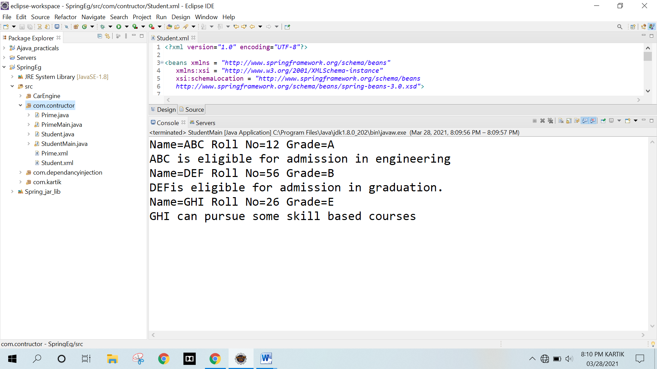

**Q.4 Car and engine program from my notes**

* 1. **ref attribute**
  2. **and inner beans**
  3. **and later two xml files**

1. **Dependecy injections using primitive and secondary data type**

**Program :**

**Car.java**

**package** CarEngine;

public class Car

{

private Engine eng;

private String carName;

public Car(Engine eng, String carName)

{

this.eng = eng;

this.carName = carName;

}

public Engine getEng()

{

return eng;

}

public String getCarName()

{

return carName;

}

public void setEng(Engine eng)

{

this.eng = eng;

}

public void setCarName(String carName)

{

this.carName = carName;

}

public void printData()

{

System.out.println("Car Name= " + carName +" Model Year= " + eng.getModelYear());

}

}

**Test.java**

package CarEngine;

import org.springframework.context.ApplicationContext;

import org.springframework.context.support.ClassPathXmlApplicationContext;

public class Test

{

public static void main(String[] args)

{

ApplicationContext context = new ClassPathXmlApplicationContext("CarEngine/appConfig.xml");

Car car = (Car)context.getBean("car");

Car car2 = (Car)context.getBean("car2");

car.printData();

car2.printData();

String files[] = new String[] {"CarEngine/Car.xml","CarEngine/Engine.xml"};

ApplicationContext context2 = new ClassPathXmlApplicationContext(files);

Car car3 = (Car)context2.getBean("car3");

car3.printData();

}

}

**Engine.java**

package CarEngine;

public class Engine

{

private String modelYear;

public Engine(String modelYear)

{

this.modelYear = modelYear;

}

public String getModelYear()

{

return modelYear;

}

public void setModelYear(String modelYear)

{

this.modelYear = modelYear;

}

}

**appConfig.xml**

<?xml version="1.0" encoding="UTF-8"?>

<beans xmlns = "http://www.springframework.org/schema/beans"

xmlns:xsi = "http://www.w3.org/2001/XMLSchema-instance"

xsi:schemaLocation = "http://www.springframework.org/schema/beans

http://www.springframework.org/schema/beans/spring-beans-3.0.xsd">

<!-- This is reference attribute -->

<bean id = "engine" class = "CarEngine.Engine">

<constructor-arg value="2015"/>

</bean>

<bean id = "car" class = "CarEngine.Car">

<constructor-arg ref="engine" type="CarEngine.Engine"/>

<constructor-arg value="Audi"/>

</bean>

<!-- This is Inner Beans -->

<bean id = "car2" class = "CarEngine.Car">

<constructor-arg>

<bean class = "CarEngine.Engine">

<constructor-arg value="2012"/>

</bean>

</constructor-arg>

<constructor-arg value="BMW"/>

</bean>

</beans>

**Car.xml**

<?xml version="1.0" encoding="UTF-8"?>

<beans xmlns = "http://www.springframework.org/schema/beans"

xmlns:xsi = "http://www.w3.org/2001/XMLSchema-instance"

xsi:schemaLocation = "http://www.springframework.org/schema/beans

http://www.springframework.org/schema/beans/spring-beans-3.0.xsd">

<!-- This is Two xml files demo -->

<bean id = "car3" class = "CarEngine.Car">

<constructor-arg ref="engine3" type="CarEngine.Engine"/>

<constructor-arg value="Ferrari"/>

</bean>

</beans>

**Engine.xml**

<?xml version="1.0" encoding="UTF-8"?>

<beans xmlns = "http://www.springframework.org/schema/beans"

xmlns:xsi = "http://www.w3.org/2001/XMLSchema-instance"

xsi:schemaLocation = "http://www.springframework.org/schema/beans

http://www.springframework.org/schema/beans/spring-beans-3.0.xsd">

<!-- This is Two xml files demo -->

<bean id = "engine3" class = "CarEngine.Engine">

<constructor-arg value="2021"/>

</bean>

</beans>

**Output :**

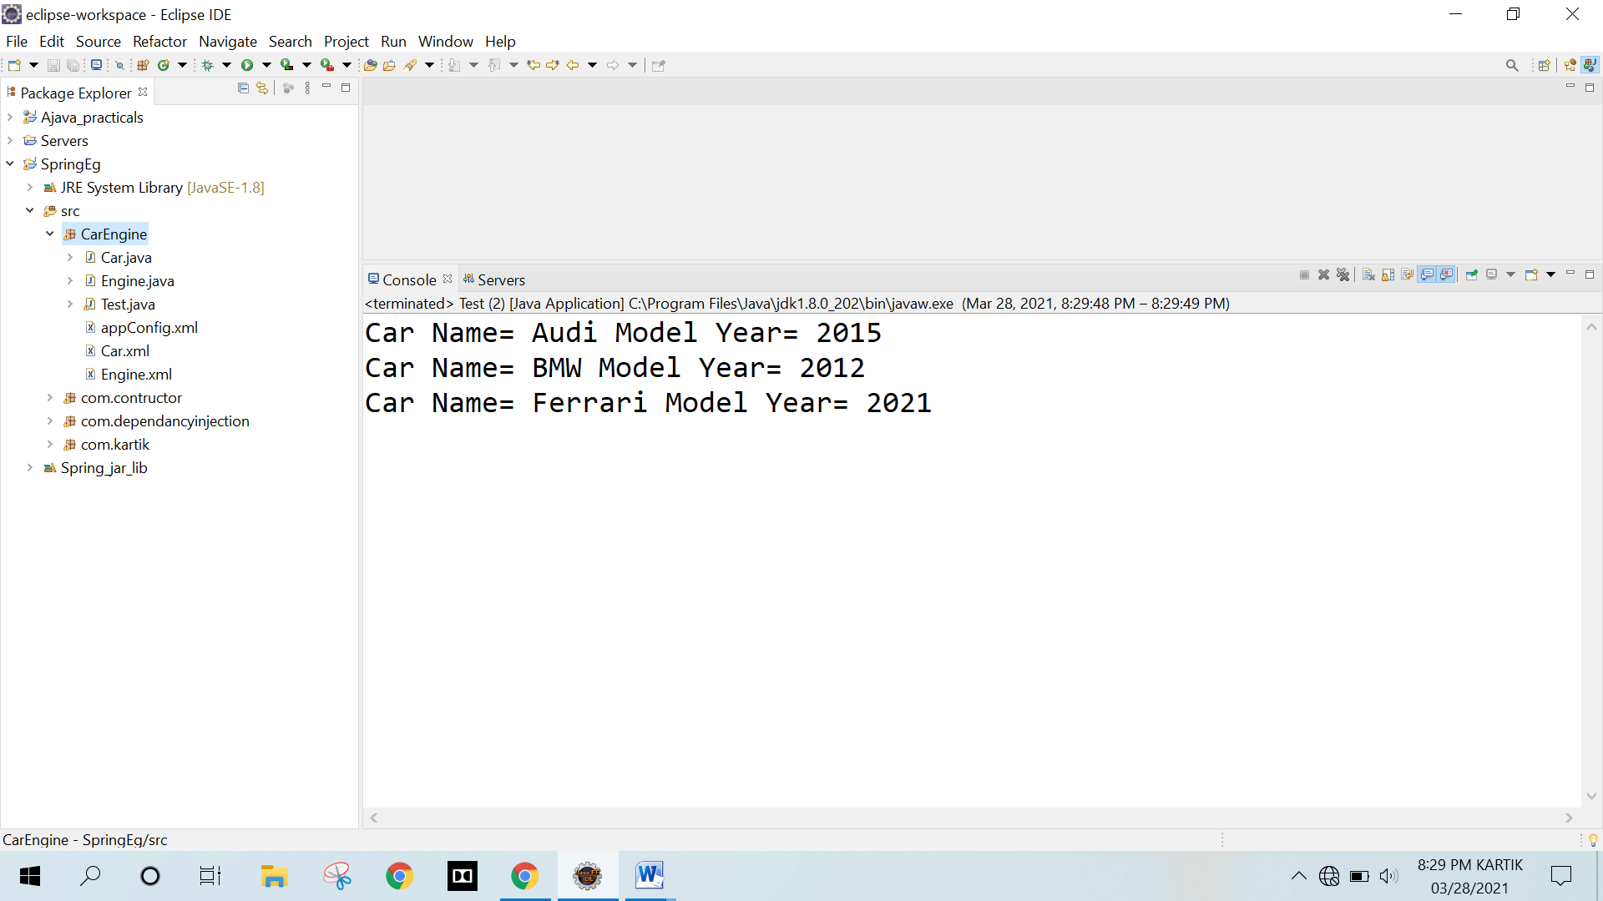

**EXPERIMENT NO. 8**

**ASSIGNMENT BASED ASPECT ORIENTED PROGRAMMING**

**EXPERIMENT NO. 8**

**ASSIGNMENT BASED ASPECT ORIENTED PROGRAMMING**

**Q.1 Write a program to demonstrate Spring AOP – before advice**

**Program:**

**ActualBussLo.java**

package com.beforeadvice;

public class ActualBussLo

{

public void m()

{

System.out.println("This is where actual business logic Exist");

}

}

**BeforeAdvisor.java**

package com.beforeadvice;

import java.lang.reflect.Method;

import org.springframework.aop.MethodBeforeAdvice;

public class BeforeAdvisor implements MethodBeforeAdvice

{

@Override

public void before(Method method, Object[] args, Object target)throws Throwable

{

System.out.println("additional concern before actual logic");

System.out.println("method info:"+method.getName()+" "+method.getModifiers());

System.out.println("argument info:");

for(Object arg:args)

System.out.println(arg);

System.out.println("target Object:"+target);

System.out.println("target object class name: "+target.getClass().getName());

}

}

**Test.java**

package com.beforeadvice;

import org.springframework.beans.factory.BeanFactory;

import org.springframework.beans.factory.xml.XmlBeanFactory;

import org.springframework.core.io.ClassPathResource;

import org.springframework.core.io.Resource;

public class Test

{

@SuppressWarnings("deprecation")

public static void main(String[] args)

{

Resource r=new ClassPathResource("com/beforeadvice/AppConfig.xml");

BeanFactory factory=new XmlBeanFactory(r);

ActualBussLo a=factory.getBean("proxy",ActualBussLo.class);

System.out.println("proxy class name: "+a.getClass().getName());

a.m();

}

}

**AppConfig.xml**

<?xml version="1.0" encoding="UTF-8"?>

<beans

xmlns="http://www.springframework.org/schema/beans"

xmlns:xsi="http://www.w3.org/2001/XMLSchema-instance"

xmlns:p="http://www.springframework.org/schema/p"

xsi:schemaLocation="http://www.springframework.org/schema/beans

http://www.springframework.org/schema/beans/spring-beans-3.0.xsd">

<bean id="obj" class="com.beforeadvice.ActualBussLo"></bean>

<bean id="ba" class="com.beforeadvice.BeforeAdvisor"></bean>

<bean id="proxy" class="org.springframework.aop.framework.ProxyFactoryBean">

<property name="target" ref="obj"></property>

<property name="interceptorNames">

<list>

<value>ba</value>

</list>

</property>

</bean>

</beans>

**Output :**

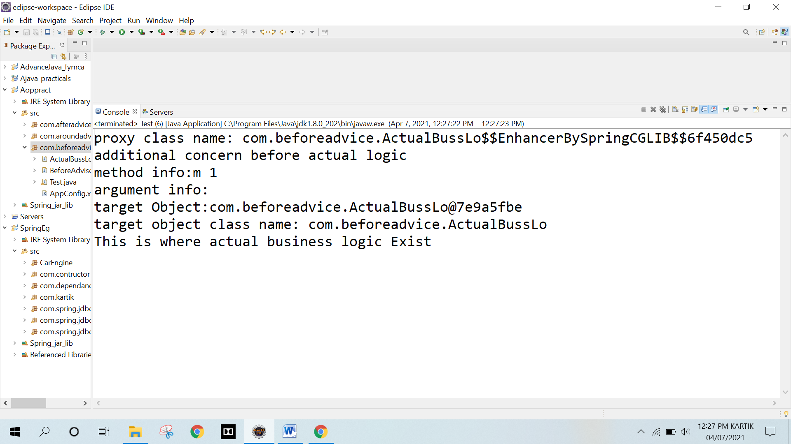

**Q.2 Write a program to demonstrate Spring AOP – after advice**

**Program:**

**ActualBussLo.java**

package com.afteradvice;

public class ActualBussLo

{

public void m()

{

System.out.println("This is where actual business logic Exist");

}

}

**AfterAdvisor.java**

package com.afteradvice;

import java.lang.reflect.Method;

import org.springframework.aop.AfterReturningAdvice;

public class AfterAdvisor implements AfterReturningAdvice

{

@Override

public void afterReturning(Object returnValue, Method method,Object[] args, Object target) throws Throwable

{

System.out.println("additional concern after returning advice");

System.out.println("method info:"+method.getName()+" "+method.getModifiers());

System.out.println("argument info:");

for(Object arg:args)

System.out.println(arg);

System.out.println("target Object:"+target);

System.out.println("target object class name: "+target.getClass().getName());

}

}

**Test.java**

package com.afteradvice;

import org.springframework.beans.factory.BeanFactory;

import org.springframework.beans.factory.xml.XmlBeanFactory;

import org.springframework.core.io.ClassPathResource;

import org.springframework.core.io.Resource;

public class Test

{

@SuppressWarnings("deprecation")

public static void main(String[] args)

{

Resource r=new ClassPathResource("com/afteradvice/AppConfig.xml");

BeanFactory factory=new XmlBeanFactory(r);

ActualBussLo a=factory.getBean("proxy",ActualBussLo.class);

System.out.println("proxy class name: "+a.getClass().getName());

a.m();

}

}

**AppConfig.xml**

<?xml version="1.0" encoding="UTF-8"?>

<beans

xmlns="http://www.springframework.org/schema/beans"

xmlns:xsi="http://www.w3.org/2001/XMLSchema-instance"

xmlns:p="http://www.springframework.org/schema/p"

xsi:schemaLocation="http://www.springframework.org/schema/beans

http://www.springframework.org/schema/beans/spring-beans-3.0.xsd">

<bean id="obj" class="com.afteradvice.ActualBussLo"></bean>

<bean id="ba" class="com.afteradvice.AfterAdvisor"></bean>

<bean id="proxy" class="org.springframework.aop.framework.ProxyFactoryBean">

<property name="target" ref="obj"></property>

<property name="interceptorNames">

<list>

<value>ba</value>

</list>

</property>

</bean>

</beans>

**Output :**

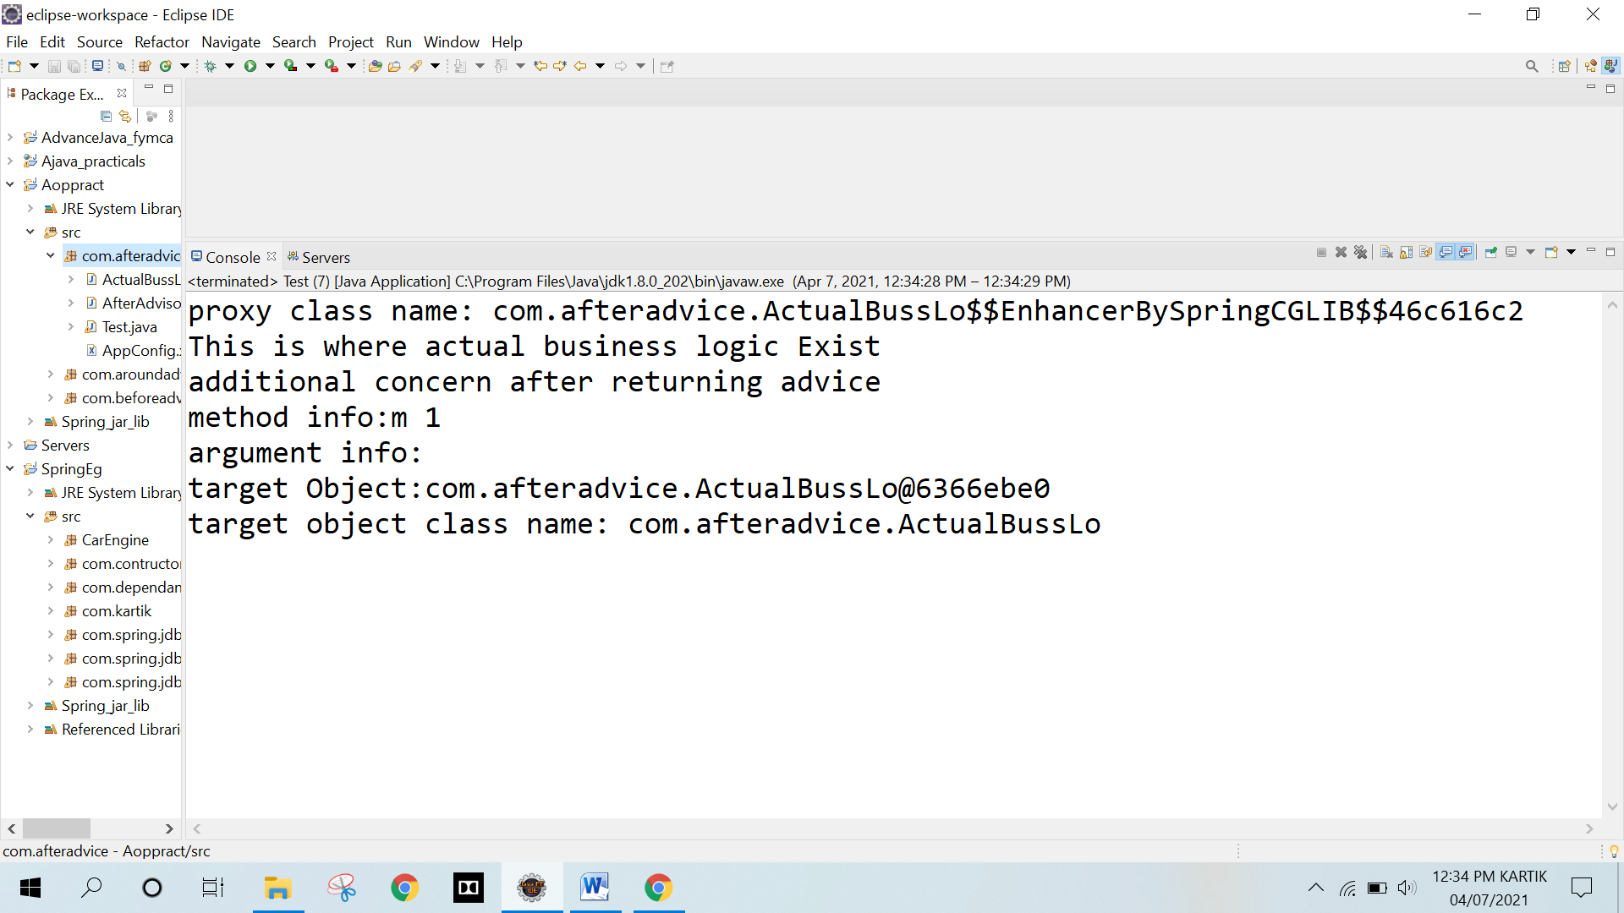

**Q. 3 Write a program to demonstrate Spring AOP – around advice.**

**Program :**

**ActualBussLo.java**

package com.aroundadvice;

public class ActualBussLo

{

public void m()

{

System.out.println("This is where actual business logic Exist");

}

}

**AroundAdvisor.java**

package com.aroundadvice;

import org.aopalliance.intercept.MethodInterceptor;

import org.aopalliance.intercept.MethodInvocation;

public class AroundAdvisor implements MethodInterceptor

{

@Override

public Object invoke(MethodInvocation mi) throws Throwable

{

Object obj;

System.out.println("additional concern before actual logic");

obj=mi.proceed();

System.out.println("additional concern after actual logic");

return obj;

}

}

**Test.java**

package com.aroundadvice;

import org.springframework.beans.factory.BeanFactory;

import org.springframework.beans.factory.xml.XmlBeanFactory;

import org.springframework.core.io.ClassPathResource;

import org.springframework.core.io.Resource;

public class Test

{

@SuppressWarnings("deprecation")

public static void main(String[] args)

{

Resource r=new ClassPathResource("com/aroundadvice/AppConfig.xml");

BeanFactory factory=new XmlBeanFactory(r);

ActualBussLo a=factory.getBean("proxy",ActualBussLo.class);

System.out.println("proxy class name: "+a.getClass().getName());

a.m();

}

}

**AppConfig.xml**

<?xml version="1.0" encoding="UTF-8"?>

<beans

xmlns="http://www.springframework.org/schema/beans"

xmlns:xsi="http://www.w3.org/2001/XMLSchema-instance"

xmlns:p="http://www.springframework.org/schema/p"

xsi:schemaLocation="http://www.springframework.org/schema/beans

http://www.springframework.org/schema/beans/spring-beans-3.0.xsd">

<bean id="obj" class="com.aroundadvice.ActualBussLo"></bean>

<bean id="ba" class="com.aroundadvice.AroundAdvisor"></bean>

<bean id="proxy" class="org.springframework.aop.framework.ProxyFactoryBean">

<property name="target" ref="obj"></property>

<property name="interceptorNames">

<list>

<value>ba</value>

</list>

</property>

</bean>

</beans>

**Output :**

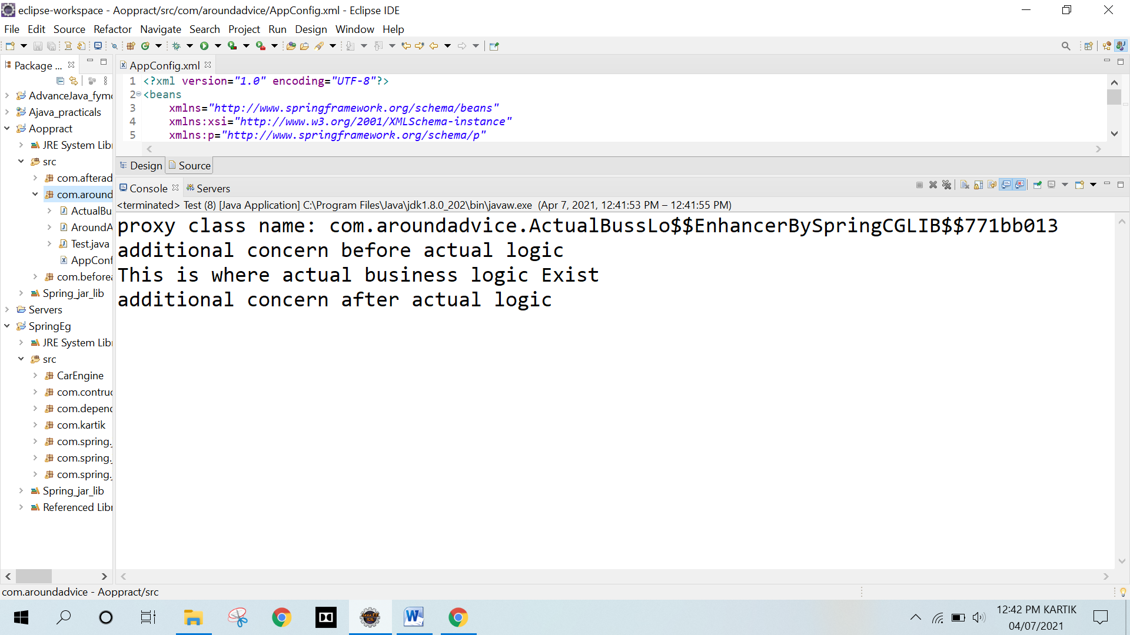

**EXPERIMENT NO. 9**

**ASSIGNMENT BASED SPRING JDBC**

**EXPERIMENT NO. 9**

**ASSIGNMENT BASED SPRING JDBC**

**Q.1 Write a program to insert, update and delete records from the given table**

**Program :**

**Student.java**

package com.spring.jdbcexample.model;

public class Student

{

// private variables

private int id;

private String name;

private int age;

// parameterized constructor

public Student(int id, String name, int age)

{

this.id = id;

this.name = name;

this.age = age;

}

// getters and setters

public int getId()

{

return id;

}

public void setId(int id)

{

this.id = id;

}

public String getName()

{

return name;

}

public void setName(String name)

{

this.name = name;

}

public int getAge()

{

return age;

}

public void setAge(int age)

{

this.age = age;

}

// a method to display data

public void show()

{

System.out.println("Id = " + id + ", Name = " + name + ", Age = " + age );

}

}

**StudentDao.java**

package com.spring.jdbcexample.model;

import com.spring.jdbcexample.model.Student;

public interface StudentDao

{

public int save(Student s) throws Exception;

public int update(Student s) throws Exception;

public int delete(int id) throws Exception;

}

**StudentDaoImpl.java**

package com.spring.jdbcexample.model;

import java.sql.Connection;

import java.sql.PreparedStatement;

import javax.sql.DataSource;

import com.spring.jdbcexample.model.StudentDao;

import com.spring.jdbcexample.model.Student;

public class StudentDaoImpl implements StudentDao

{

private DataSource ds;

private Connection con;

public void setDs(DataSource ds)

{

this.ds = ds;

}

@Override

public int save(Student s) throws Exception

{

con = ds.getConnection();

String sql = "insert into student values(?,?,?)";

PreparedStatement ps = con.prepareStatement(sql);

ps.setInt(1, s.getId());

ps.setString(2, s.getName());

ps.setInt(3, s.getAge());

return ps.executeUpdate();

}

@Override

public int update(Student s) throws Exception

{

con = ds.getConnection();

String sql = "update student set name=?, age=? where id=?";

PreparedStatement ps = con.prepareStatement(sql);

ps.setString(1, s.getName());

ps.setInt(2, s.getAge());

ps.setInt(3, s.getId());

return ps.executeUpdate();

}

@Override

public int delete(int id) throws Exception

{

con = ds.getConnection();

String sql = "delete from student where id=?";

PreparedStatement ps = con.prepareStatement(sql);

ps.setInt(1, id);

return ps.executeUpdate();

}

}

**Test.java**

package com.spring.jdbcexample.model;

import org.springframework.context.ApplicationContext;

import org.springframework.context.support.ClassPathXmlApplicationContext;

import com.spring.jdbcexample.model.StudentDao;

import com.spring.jdbcexample.model.StudentDaoImpl;

import com.spring.jdbcexample.model.Student;

public class Test

{

public static void main(String[] args)throws Exception

{

// Loading bean configuration file

ApplicationContext ac = new ClassPathXmlApplicationContext("com/spring/jdbcexample/model/appConfig.xml");

// using required bean

StudentDao dao = (StudentDaoImpl)ac.getBean("dao");

// Creating Student object

Student s1 = new Student(53, "Ankita", 24);

Student s2 = new Student(30, "Shubham", 24);

Student s3 = new Student(41, "Saloni", 23);

// Saving Student obj in db

int check1 = dao.save(s1);

int check2 = dao.save(s2);

int check3 = dao.save(s3);

System.out.println("\nChecking if inserted?");

System.out.println((check1>0) ? "1st Record Inserted" : "1st Record Not Inserted");

System.out.println((check2>0) ? "2nd Record Inserted" : "2nd Record Not Inserted");

System.out.println((check3>0) ? "3rd Record Inserted" : "3rd Record Not Inserted");

Student s1 = new Student(53, "Ankita Singh", 24);

Student s2 = new Student(30, "Shubham Lokhande", 24);

Student s3 = new Student(41, "Shivani Parab", 23);

s1.setName("Ankita Singh");

s2.setName("Shubham Lokhande");

s3.setName("Shivani Parab");

int update1 = dao.update(s1);

int update2 = dao.update(s2);

int update3 = dao.update(s3);

System.out.println("\nChecking if updated?");

System.out.println((update1>0) ? "1st Record Updated" : "1st Record Not Updated");

System.out.println((update2>0) ? "2nd Record Updated" : "2nd Record Not Updated");

System.out.println((update3>0) ? "3rd Record Updated" : "3rd Record Not Updated");

int delete1 = dao.delete(53);

int delete2 = dao.delete(41);

System.out.println("\nChecking if deleted?");

System.out.println((delete1>0) ? "1st Record Deleted" : "1st Record Not Deleted");

System.out.println((delete2>0) ? "2nd Record Deleted" : "2nd Record Not Deleted");

}

}

**appConfig.xml**

<?xml version="1.0" encoding="UTF-8"?>

<beans xmlns="http://www.springframework.org/schema/beans"

xmlns:xsi="http://www.w3.org/2001/XMLSchema-instance"

xmlns:p="http://www.springframework.org/schema/p"

xsi:schemaLocation="http://www.springframework.org/schema/beans

http://www.springframework.org/schema/beans/spring-beans-3.0.xsd">

<bean id="bds" class="org.springframework.jdbc.datasource.DriverManagerDataSource">

<property name="driverClassName" value="com.mysql.cj.jdbc.Driver" />

<property name="url" value="jdbc:mysql://localhost:3306/kartik" />

<property name="username" value="root" />

<property name="password" value="" />

</bean>

<bean id="dao" class="com.spring.jdbcexample.model.StudentDaoImpl">

<property name="ds" ref="bds" />

</bean>

</beans>

**Ouput :**

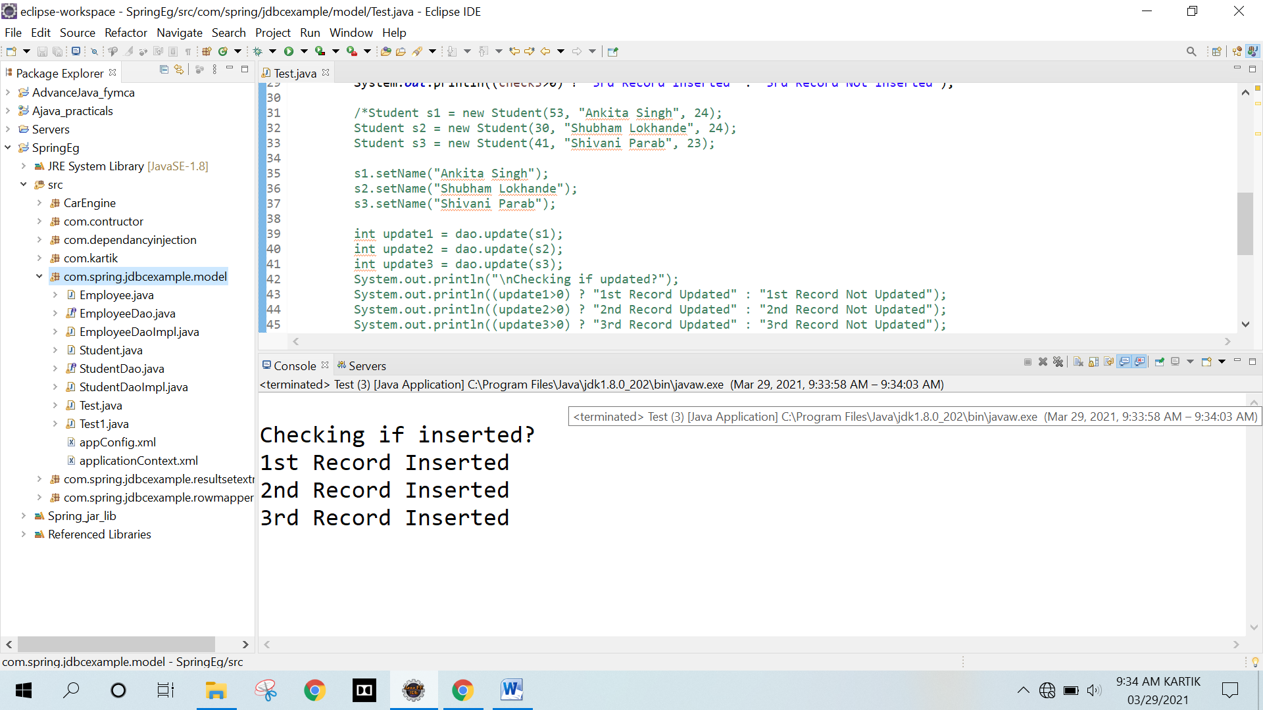

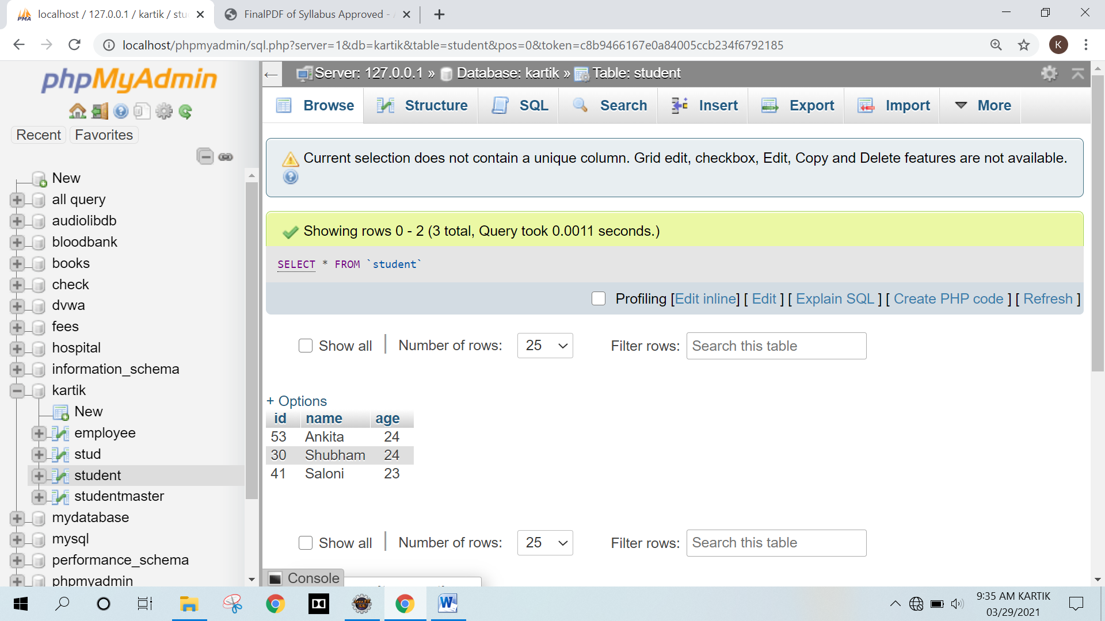

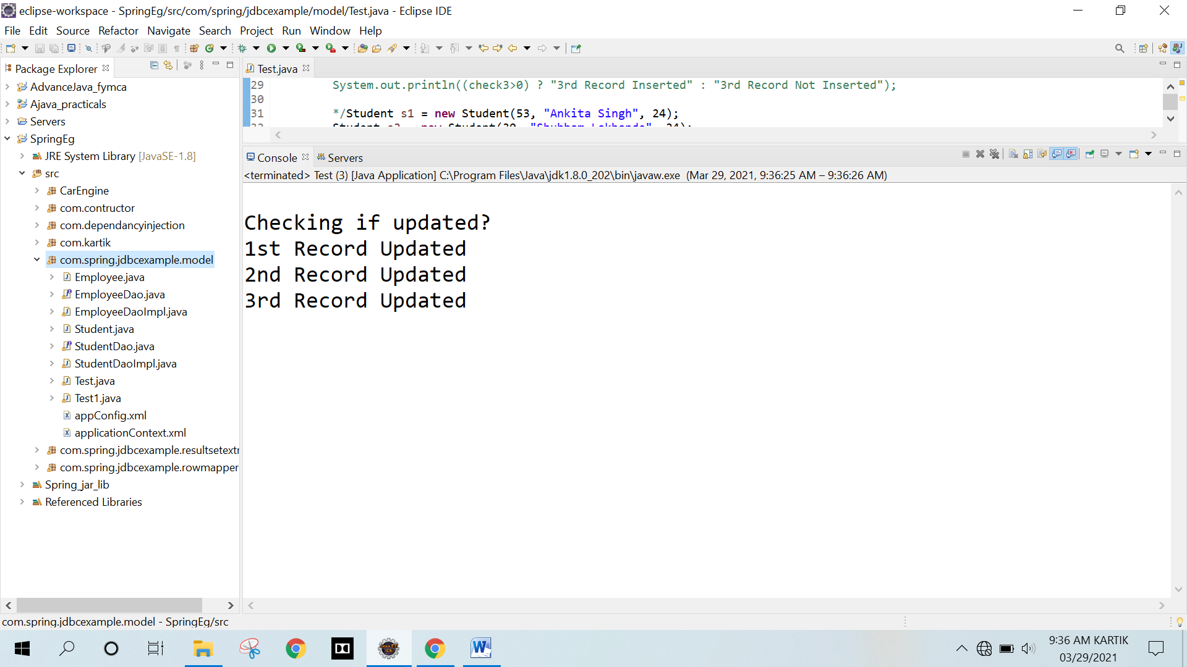

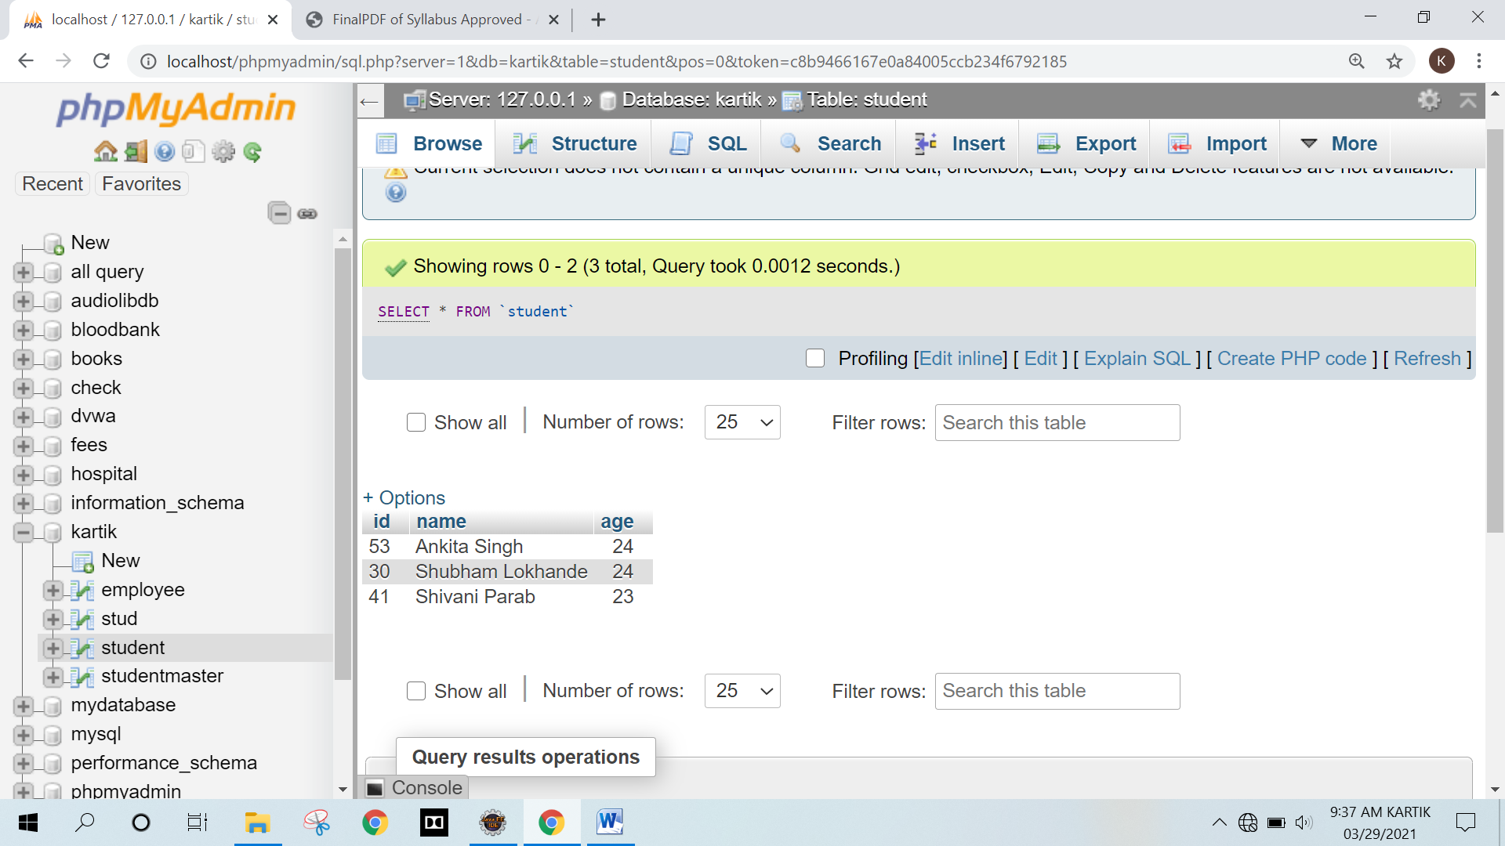

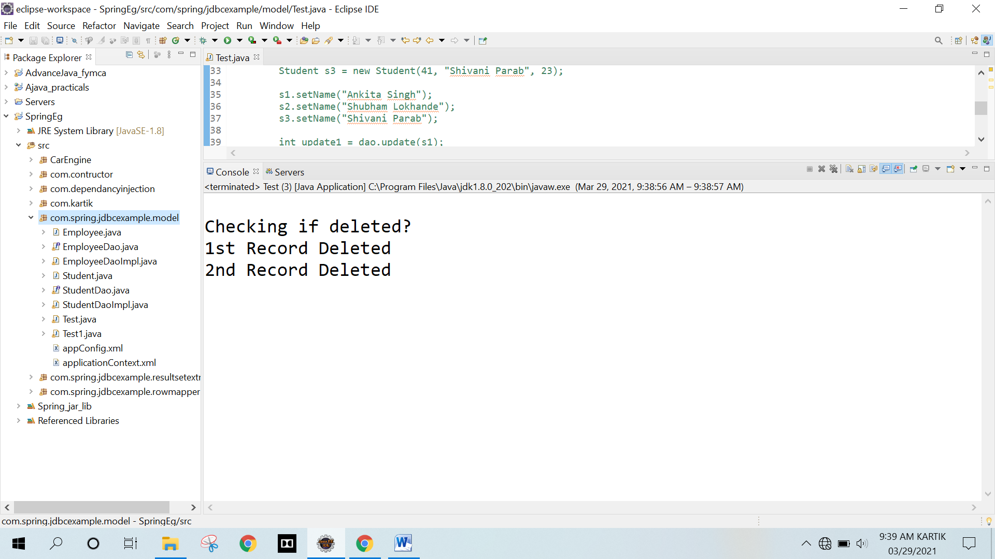

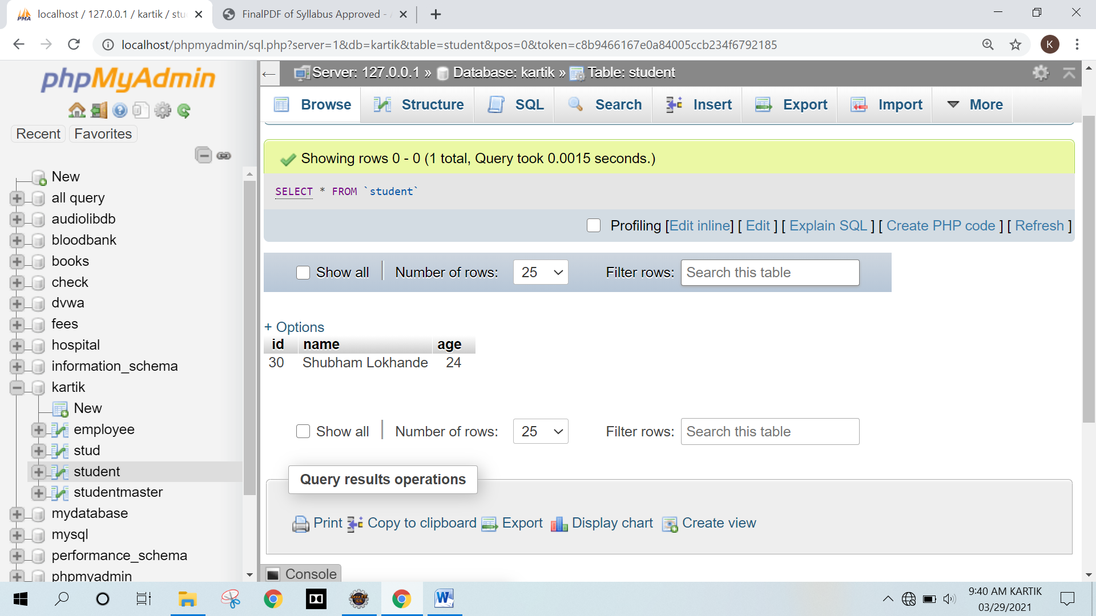

**Q.2 Write a program to demonstrate PreparedStatement in Spring JdbcTemplate**

**Program:**

**Employee.java**

package com.spring.jdbcexample.model;

public class Employee

{

private int id;

private String name;

private float salary;

public Employee(int id, String name, float salary)

{

this.id = id;

this.name = name;

this.salary = salary;

}

public int getId()

{

return id;

}

public void setId(int id)

{

this.id = id;

}

public String getName()

{

return name;

}

public void setName(String name)

{

this.name = name;

}

public float getSalary()

{

return salary;

}

public void setSalary(float salary)

{

this.salary = salary;

}

public void show()

{

System.out.println("Employee [id=" + id + ", name=" + name + ", salary=" + salary + "]");

}

}

**EmployeeDao.java**

package com.spring.jdbcexample.model;

import com.spring.jdbcexample.model.Employee;

public interface EmployeeDao

{

public int saveEmployee(Employee e);

public int updateEmployee(Employee e);

}

EmployeeDaoImpl.java

package com.spring.jdbcexample.model;

import java.sql.PreparedStatement;

import java.sql.SQLException;

import java.util.List;

import org.springframework.dao.DataAccessException;

import org.springframework.jdbc.core.JdbcTemplate;

import org.springframework.jdbc.core.PreparedStatementCallback;

import com.spring.jdbcexample.model.EmployeeDao;

import com.spring.jdbcexample.model.Employee;

public class EmployeeDaoImpl implements EmployeeDao

{

private JdbcTemplate jdbcTempl;

public void setJdbcTempl(JdbcTemplate jdbcTempl)

{

this.jdbcTempl = jdbcTempl;

}

@Override

public int saveEmployee(Employee e)

{

String query="insert into employee values(?,?,?)";

return jdbcTempl.execute(query, new PreparedStatementCallback<Integer>()

{

@Override

public Integer doInPreparedStatement(PreparedStatement ps)throws SQLException, DataAccessException

{

ps.setInt(1, e.getId());

ps.setString(2, e.getName());

ps.setFloat(3, e.getSalary());

return ps.executeUpdate();

}

});

}

@Override

public int updateEmployee(Employee e)

{

String query="update employee set name=?,salary=? where id=?";

return jdbcTempl.execute(query, new PreparedStatementCallback<Integer>()

{

@Override

public Integer doInPreparedStatement(PreparedStatement ps)throws SQLException, DataAccessException

{

ps.setString(1, e.getName());

ps.setFloat(2, e.getSalary());

ps.setInt(3, e.getId());

return ps.executeUpdate();

}

});

}

}

**applicationContext.xml**

<?xml version="1.0" encoding="UTF-8"?>

<beans xmlns="http://www.springframework.org/schema/beans"

xmlns:xsi="http://www.w3.org/2001/XMLSchema-instance"

xmlns:p="http://www.springframework.org/schema/p"

xsi:schemaLocation="http://www.springframework.org/schema/beans

http://www.springframework.org/schema/beans/spring-beans-3.0.xsd">

<bean id="ds" class="org.springframework.jdbc.datasource.DriverManagerDataSource">

<property name="driverClassName" value="com.mysql.cj.jdbc.Driver" />

<property name="url" value="jdbc:mysql://localhost:3306/kartik" />

<property name="username" value="root" />

<property name="password" value="" />

</bean>

<bean id="jdbcTempl" class="org.springframework.jdbc.core.JdbcTemplate">

<property name="dataSource" ref="ds"></property>

</bean>

<bean id="edao" class="com.spring.jdbcexample.model.EmployeeDaoImpl">

<property name="jdbcTempl" ref="jdbcTempl"/>

</bean>

</beans>

**Test1.java**

package com.spring.jdbcexample.model;

import org.springframework.context.ApplicationContext;

import org.springframework.context.support.ClassPathXmlApplicationContext;

import com.spring.jdbcexample.model.EmployeeDao;

import com.spring.jdbcexample.model.EmployeeDaoImpl;

import com.spring.jdbcexample.model.Employee;

public class Test1

{

public static void main(String[] args)

{

// Loading bean configuration file

ApplicationContext ctx=new

ClassPathXmlApplicationContext("com/spring/jdbcexample/model/applicationContext.xml");

EmployeeDao dao=(EmployeeDaoImpl)ctx.getBean("edao");

// Inserting into bean

int insert1 = dao.saveEmployee(new Employee(101,"Shubham",15000));

int insert2 = dao.saveEmployee(new Employee(102,"Rahul",35000));

System.out.println("\nChecking if record inserted?");

System.out.println((insert1>0) ? "1st Record Inserted" : "1st Record Not Inserted");

System.out.println((insert2>0) ? "2nd Record Inserted" : "2nd Record Not Inserted");

int update1 = dao.updateEmployee(new Employee(101,"Shubham Lokhande",20000));

int update2 = dao.updateEmployee(new Employee(102,"Rahul Singh",35000));

System.out.println("\nChecking if record updated?");

System.out.println((update1>0) ? "1st Record Updated" : "1st Record Not Updated");

System.out.println((update2>0) ? "2nd Record Updated" : "2nd Record Not Updated");

}

}

**EmployeeDaoImpl.java**

package com.spring.jdbcexample.model;

import java.sql.PreparedStatement;

import java.sql.SQLException;

import java.util.List;

import org.springframework.dao.DataAccessException;

import org.springframework.jdbc.core.JdbcTemplate;

import org.springframework.jdbc.core.PreparedStatementCallback;

import com.spring.jdbcexample.model.EmployeeDao;

import com.spring.jdbcexample.model.Employee;

public class EmployeeDaoImpl implements EmployeeDao

{

private JdbcTemplate jdbcTempl;

public void setJdbcTempl(JdbcTemplate jdbcTempl)

{

this.jdbcTempl = jdbcTempl;

}

@Override

public int saveEmployee(Employee e)

{

String query="insert into employee values(?,?,?)";

return jdbcTempl.execute(query, new PreparedStatementCallback<Integer>()

{

@Override

public Integer doInPreparedStatement(PreparedStatement ps)throws SQLException, DataAccessException

{

ps.setInt(1, e.getId());

ps.setString(2, e.getName());

ps.setFloat(3, e.getSalary());

return ps.executeUpdate();

}

});

}

@Override

public int updateEmployee(Employee e)

{

String query="update employee set name=?,salary=? where id=?";

return jdbcTempl.execute(query, new PreparedStatementCallback<Integer>()

{

@Override

public Integer doInPreparedStatement(PreparedStatement ps)throws SQLException, DataAccessException

{

ps.setString(1, e.getName());

ps.setFloat(2, e.getSalary());

ps.setInt(3, e.getId());

return ps.executeUpdate();

}

});

}

}

**Ouput :**

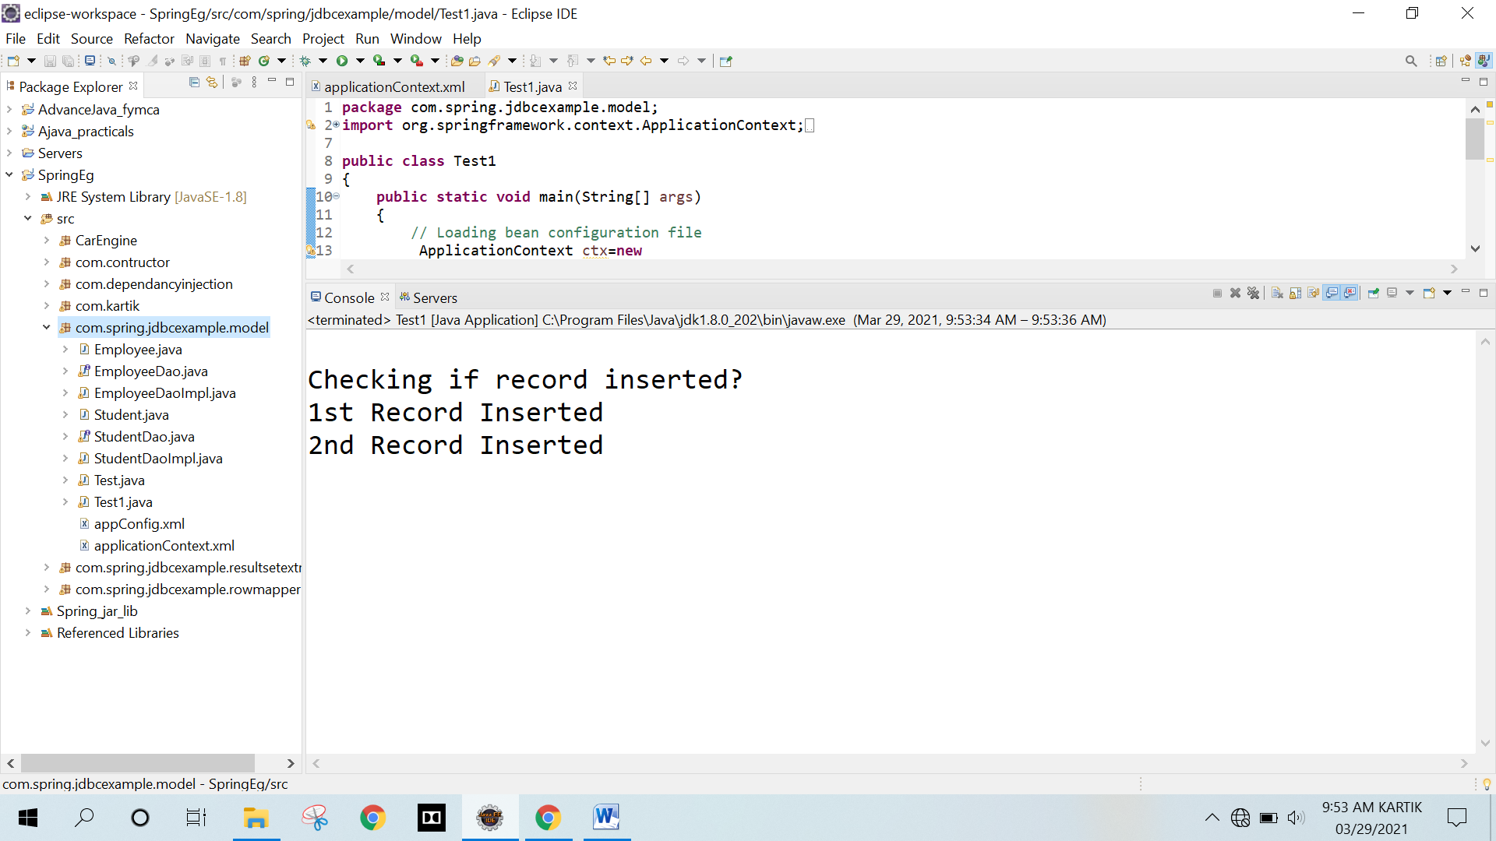

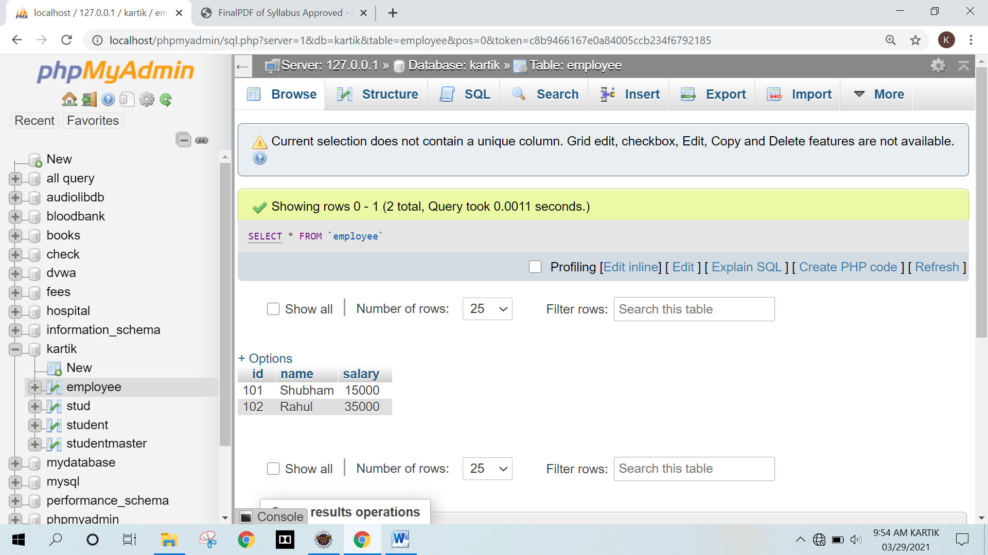

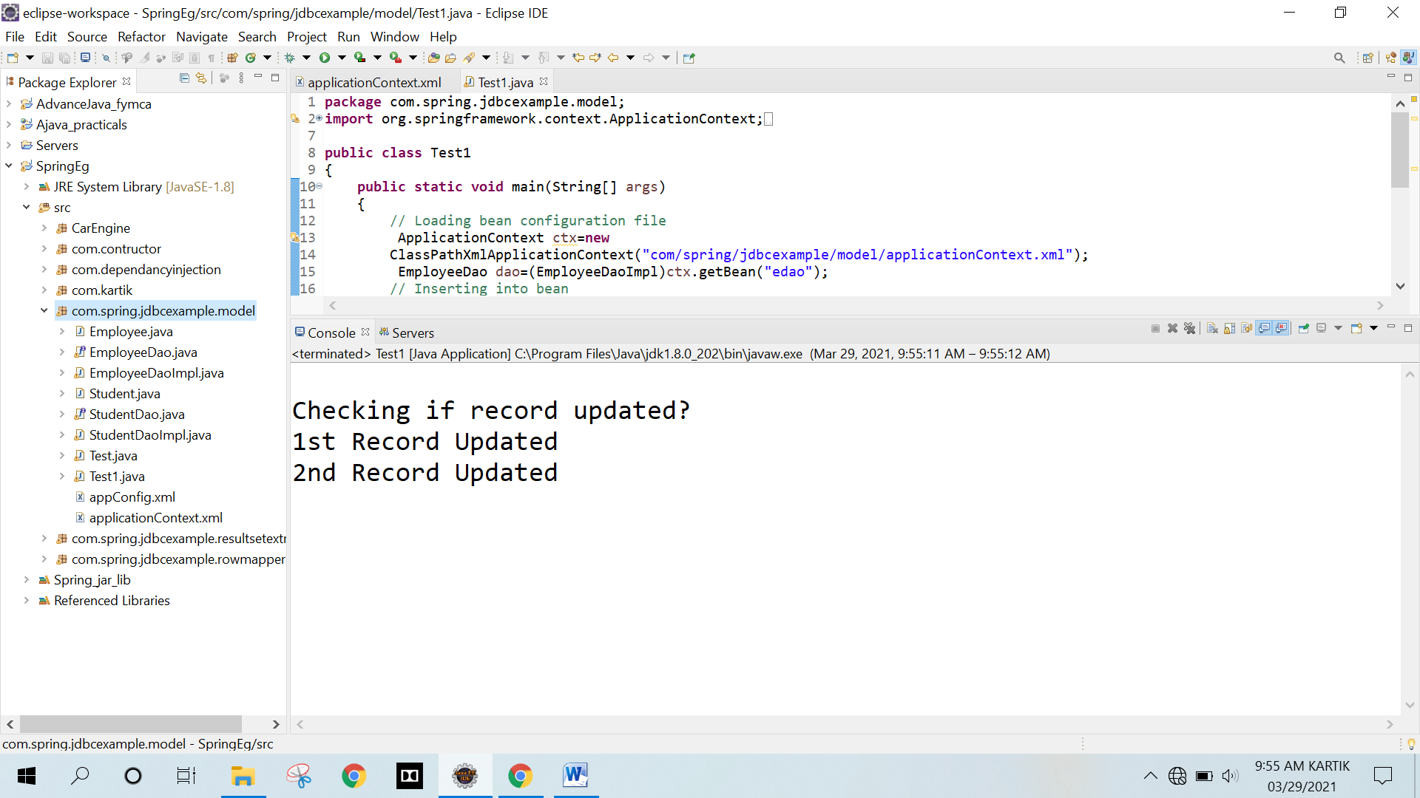

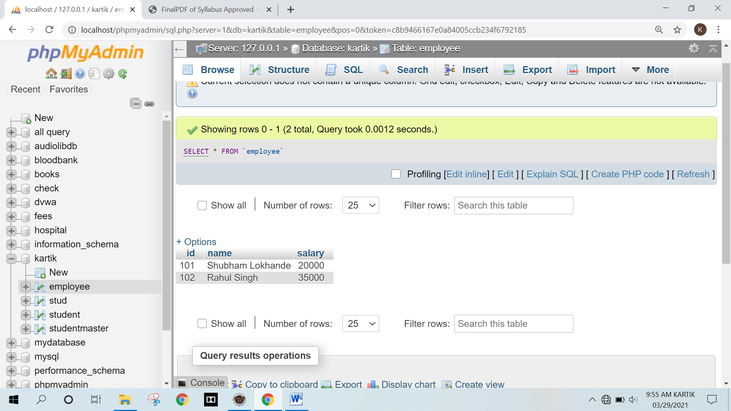

**Q.3 Write a program in Spring JDBC to demonstrate ResultSetExtractor Interface**

**Program :**

**Employee.java**

package com.spring.jdbcexample.resultsetextractor;

public class Employee

{

private int id;

private String name;

private float salary;

// default constructor

public Employee()

{

}

// Parameterized constructor

public Employee(int id, String name, float salary)

{

this.id = id;

this.name = name;

this.salary = salary;

}

// getters and setters

public int getId()

{

return id;

}

public void setId(int id)

{

this.id = id;

}

public String getName()

{

return name;

}

public void setName(String name)

{

this.name = name;

}

public float getSalary()

{

return salary;

}

public void setSalary(float salary)

{

this.salary = salary;

}

// method to display data

public void show()

{

System.out.println("Employee [id=" + id + ", name=" + name + ", salary=" + salary + "]");

}

}

**EmployeeDao.java**

package com.spring.jdbcexample.resultsetextractor

import java.util.List;

import com.spring.jdbcexample.resultsetextractor.Employee;

public interface EmployeeDao

{

public int saveEmployee(Employee e);

public int updateEmployee(Employee e);

public List<Employee> getAllEmployee();

}

**EmployeeDaoImpl.java**

package com.spring.jdbcexample.resultsetextractor;

import java.sql.PreparedStatement;

import java.sql.ResultSet;

import java.sql.SQLException;

import java.util.ArrayList;

import java.util.List;

import org.springframework.dao.DataAccessException;

import org.springframework.jdbc.core.JdbcTemplate;

import org.springframework.jdbc.core.PreparedStatementCallback;

import org.springframework.jdbc.core.ResultSetExtractor;

import com.spring.jdbcexample.resultsetextractor.EmployeeDao;

import com.spring.jdbcexample.resultsetextractor.Employee;

public class EmployeeDaoImpl implements EmployeeDao

{

private JdbcTemplate jdbcTempl;

public void setJdbcTempl(JdbcTemplate jdbcTempl)

{

this.jdbcTempl = jdbcTempl;

}

@Override

public int saveEmployee(Employee e)

{

String query="insert into employee values(?,?,?)";

return jdbcTempl.execute(query, new PreparedStatementCallback<Integer>()

{

@Override

public Integer doInPreparedStatement(PreparedStatement ps)throws SQLException, DataAccessException

{

ps.setInt(1, e.getId());

ps.setString(2, e.getName());

ps.setFloat(3, e.getSalary());

return ps.executeUpdate();

}

});

}

@Override

public int updateEmployee(Employee e)

{

String query="update employee set name=?,salary=? where id=?";

return jdbcTempl.execute(query, new PreparedStatementCallback<Integer>()

{

@Override

public Integer doInPreparedStatement(PreparedStatement ps) throws SQLException, DataAccessException

{

ps.setString(1, e.getName());

ps.setFloat(2, e.getSalary());

ps.setInt(3, e.getId());

return ps.executeUpdate();

}

});

}

@Override

public List<Employee> getAllEmployee()

{

return jdbcTempl.query("select * from employee", new ResultSetExtractor<List<Employee>>()

{

@Override

public List<Employee> extractData(ResultSet rs) throws SQLException, DataAccessException

{

List<Employee> empList=new ArrayList<>();

while(rs.next())

{

Employee e=new Employee();

e.setId(rs.getInt(1));

e.setName(rs.getString(2));

e.setSalary(rs.getFloat(3));

empList.add(e);

}

return empList;

}

});

}

}

**applicationContext.xml**

<?xml version="1.0" encoding="UTF-8"?>

<beans

xmlns="http://www.springframework.org/schema/beans"

xmlns:xsi="http://www.w3.org/2001/XMLSchema-instance"

xmlns:p="http://www.springframework.org/schema/p"

xsi:schemaLocation="http://www.springframework.org/schema/beans

http://www.springframework.org/schema/beans/spring-beans-3.0.xsd">

<bean id="ds" class="org.springframework.jdbc.datasource.DriverManagerDataSource">

<property name="driverClassName" value="com.mysql.cj.jdbc.Driver" />

<property name="url" value="jdbc:mysql://localhost:3306/kartik" />

<property name="username" value="root" />

<property name="password" value="" />

</bean>

<bean id="jdbcTempl" class="org.springframework.jdbc.core.JdbcTemplate">

<property name="dataSource" ref="ds"></property>

</bean>

<bean id="edao" class="com.spring.jdbcexample.resultsetextractor.EmployeeDaoImpl">

<property name="jdbcTempl" ref="jdbcTempl"/>

</bean>

</beans>

**Test.java**

package com.spring.jdbcexample.resultsetextractor;

import java.util.List;

import org.springframework.context.ApplicationContext;

import org.springframework.context.support.ClassPathXmlApplicationContext;

import com.spring.jdbcexample.resultsetextractor.EmployeeDao;

import com.spring.jdbcexample.resultsetextractor.EmployeeDaoImpl;

import com.spring.jdbcexample.resultsetextractor.Employee;

public class Test

{

public static void main(String[] args) throws Exception

{

// Loading bean configuration file

ApplicationContext ctx=new ClassPathXmlApplicationContext("com/spring/jdbcexample/resultsetextractor/applicationContext.xml");

EmployeeDao dao=(EmployeeDaoImpl)ctx.getBean("edao");

// Inserting into bean

int insert1 = dao.saveEmployee(new Employee(101,"Shubham",15000));

int insert2 = dao.saveEmployee(new Employee(102,"Rahul",35000));

System.out.println("\nChecking if record inserted?");

System.out.println((insert1>0) ? "1st Record Inserted" : "1st Record Not Inserted");

System.out.println((insert2>0) ? "2nd Record Inserted" : "2nd Record Not Inserted");

// Printing all records from database

System.out.println("\nShowing all records from Database");

List<Employee> empList = dao.getAllEmployee();

for (Employee employee : empList)

employee.show();

}

}

**Output :**

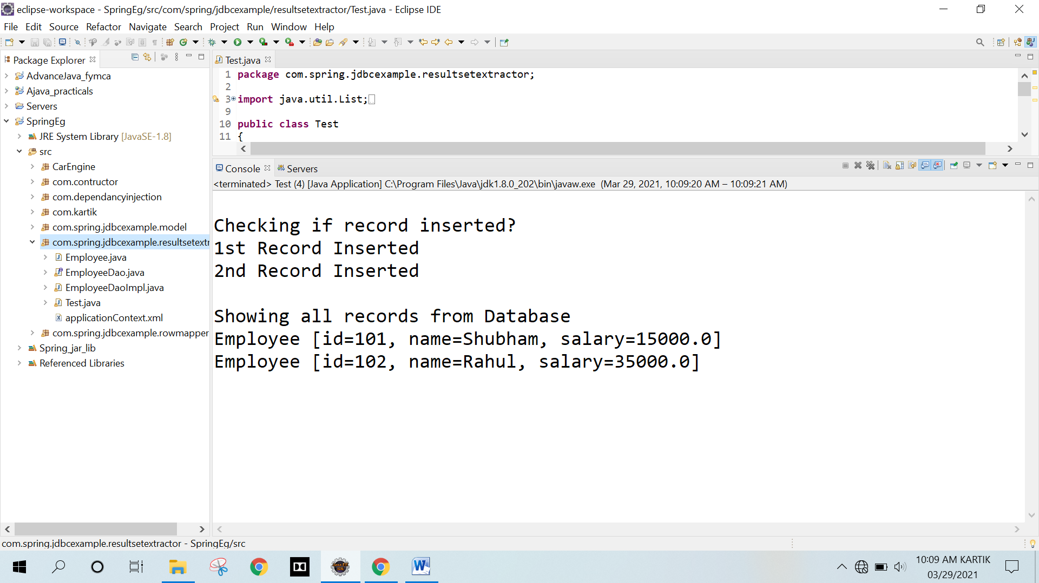

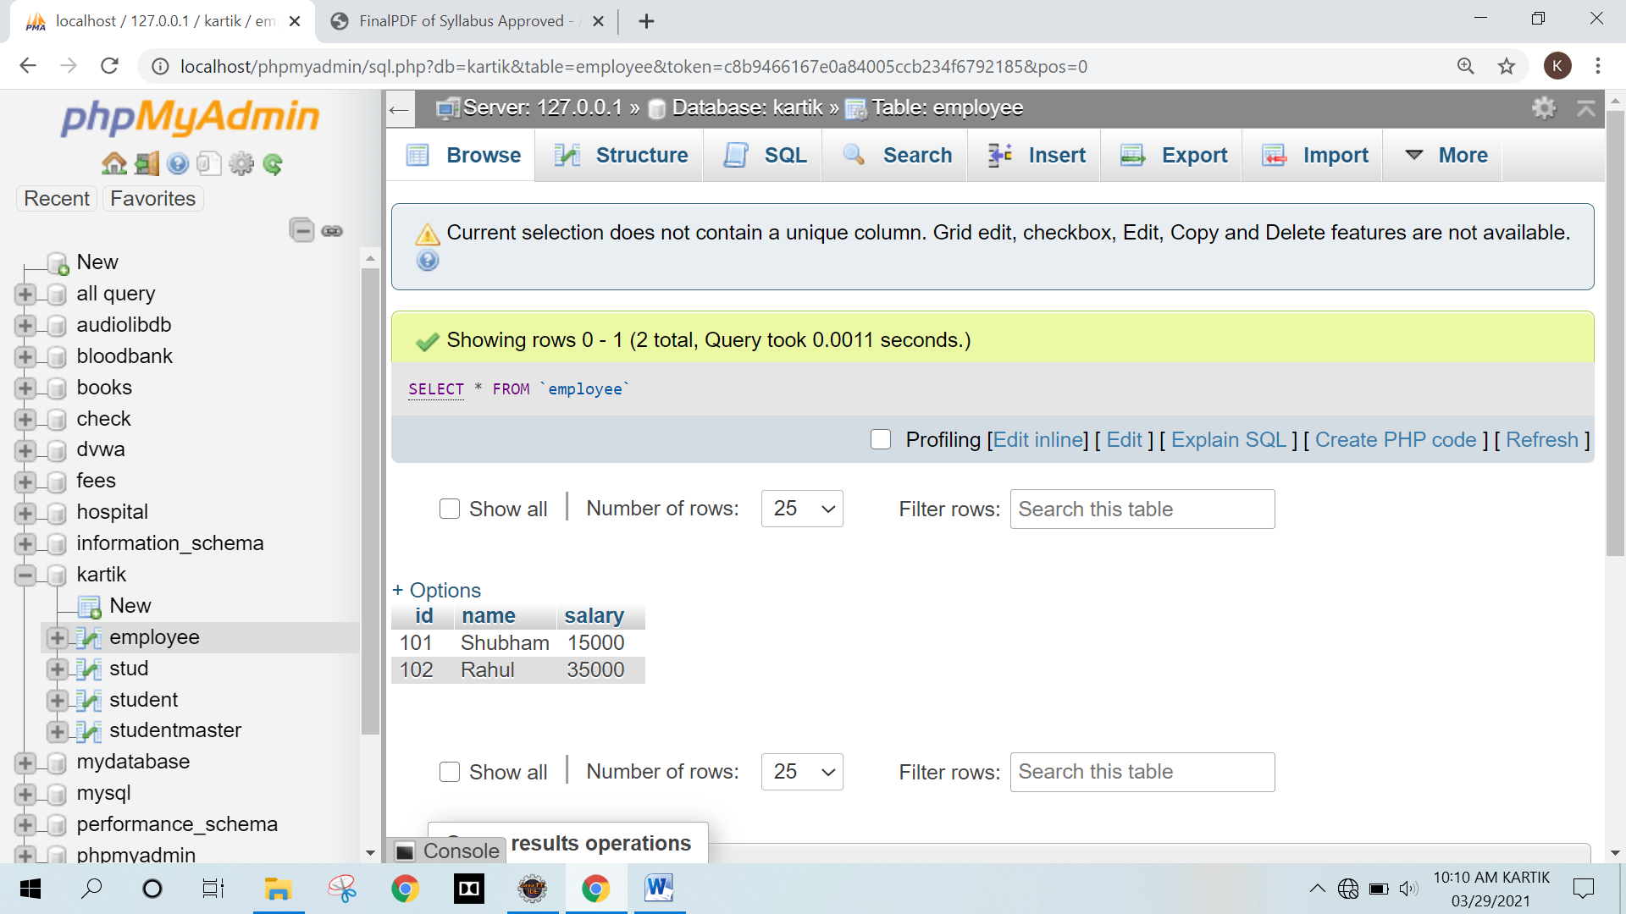

**Q.4 Write a program to demonstrate RowMapper interface to fetch the records from the database.**

**Program :**

**Employee.java**

package com.spring.jdbcexample.rowmapper;

public class Employee

{

private int id;

private String name;

private float salary;

// default constructor

public Employee() {}

// Parameterized constructor

public Employee(int id, String name, float salary) {

this.id = id;

this.name = name;

this.salary = salary;

}

// getters and setters

public int getId() {

return id;

}

public void setId(int id) {

this.id = id;

}

public String getName() {

return name;

}

public void setName(String name) {

this.name = name;

}

public float getSalary() {

return salary;

}

public void setSalary(float salary) {

this.salary = salary;

}

// method to display data

public void show() {

System.out.println("Employee [id=" + id + ", name=" + name + ", salary=" + salary + "]");

}

}

**EmployeeDao.java**

package com.spring.jdbcexample.rowmapper;

import java.util.List;

import com.spring.jdbcexample.rowmapper.Employee;

public interface EmployeeDao

{

public int saveEmployee(Employee e);

public int updateEmployee(Employee e);

public List<Employee> getAllEmployee();

}

**EmployeeDaoImpl.java**

package com.spring.jdbcexample.rowmapper;

import java.sql.PreparedStatement;

import java.sql.ResultSet;

import java.sql.SQLException;

import java.util.List;

import org.springframework.dao.DataAccessException;

import org.springframework.jdbc.core.JdbcTemplate;

import org.springframework.jdbc.core.PreparedStatementCallback;

import org.springframework.jdbc.core.RowMapper;

import com.spring.jdbcexample.rowmapper.EmployeeDao;

import com.spring.jdbcexample.rowmapper.Employee;

public class EmployeeDaoImpl implements EmployeeDao

{

private JdbcTemplate jdbcTempl;

public void setJdbcTempl(JdbcTemplate jdbcTempl)

{

this.jdbcTempl = jdbcTempl;

}

@Override

public int saveEmployee(Employee e)

{

String query="insert into employee values(?,?,?)";

return jdbcTempl.execute(query, new PreparedStatementCallback<Integer>()

{

@Override

public Integer doInPreparedStatement(PreparedStatement ps)throws SQLException, DataAccessException

{

ps.setInt(1, e.getId());

ps.setString(2, e.getName());

ps.setFloat(3, e.getSalary());

return ps.executeUpdate();

}

});

}

@Override

public int updateEmployee(Employee e)

{

String query="update employee set name=?,salary=? where id=?";

return jdbcTempl.execute(query, new PreparedStatementCallback<Integer>()

{

@Override

public Integer doInPreparedStatement(PreparedStatement ps)throws SQLException, DataAccessException

{

ps.setString(1, e.getName());

ps.setFloat(2, e.getSalary());

ps.setInt(3, e.getId());

return ps.executeUpdate();

}

});

}

@Override

public List<Employee> getAllEmployee()

{

return jdbcTempl.query("select * from employee", new RowMapper<Employee>()

{

@Override

public Employee mapRow(ResultSet rs, int rownumber) throws SQLException

{

Employee e=new Employee();

e.setId(rs.getInt(1));

e.setName(rs.getString(2));

e.setSalary(rs.getFloat(3));

return e;

}

});

}

}

**applicationContext.xml**

<?xml version="1.0" encoding="UTF-8"?>

<beans

xmlns="http://www.springframework.org/schema/beans"

xmlns:xsi="http://www.w3.org/2001/XMLSchema-instance"

xmlns:p="http://www.springframework.org/schema/p"

xsi:schemaLocation="http://www.springframework.org/schema/beans

http://www.springframework.org/schema/beans/spring-beans-3.0.xsd">

<bean id="ds" class="org.springframework.jdbc.datasource.DriverManagerDataSource">

<property name="driverClassName" value="com.mysql.cj.jdbc.Driver" />

<property name="url" value="jdbc:mysql://localhost:3306/kartik" />

<property name="username" value="root" />

<property name="password" value="" />

</bean>

<bean id="jdbcTempl" class="org.springframework.jdbc.core.JdbcTemplate">

<property name="dataSource" ref="ds"></property>

</bean>

<bean id="edao" class="com.spring.jdbcexample.rowmapper.EmployeeDaoImpl">

<property name="jdbcTempl" ref="jdbcTempl"/>

</bean>

</beans>

**Test.java**

package com.spring.jdbcexample.rowmapper;

import java.util.List;

import org.springframework.context.ApplicationContext;

import org.springframework.context.support.ClassPathXmlApplicationContext;

import com.spring.jdbcexample.rowmapper.EmployeeDao;

import com.spring.jdbcexample.rowmapper.EmployeeDaoImpl;

import com.spring.jdbcexample.rowmapper.Employee;

public class Test

{

public static void main(String[] args) throws Exception

{

// Loading bean configuration file

ApplicationContext ctx=new

ClassPathXmlApplicationContext("com/spring/jdbcexample/rowmapper/applicationContext.xml");

EmployeeDao dao=(EmployeeDaoImpl)ctx.getBean("edao");

// Inserting into bean

int insert1 = dao.saveEmployee(new Employee(101,"Shubham",15000));

int insert2 = dao.saveEmployee(new Employee(102,"Rahul",35000));

System.out.println("\nChecking if record inserted?");

System.out.println((insert1>0) ? "1st Record Inserted" : "1st Record Not Inserted");

System.out.println((insert2>0) ? "2nd Record Inserted" : "2nd Record Not Inserted");

// Printing all records from database

System.out.println("\nShowing all records from Database");

List<Employee> empList = dao.getAllEmployee();

for (Employee employee : empList)

employee.show();

}

}

**Output :**

